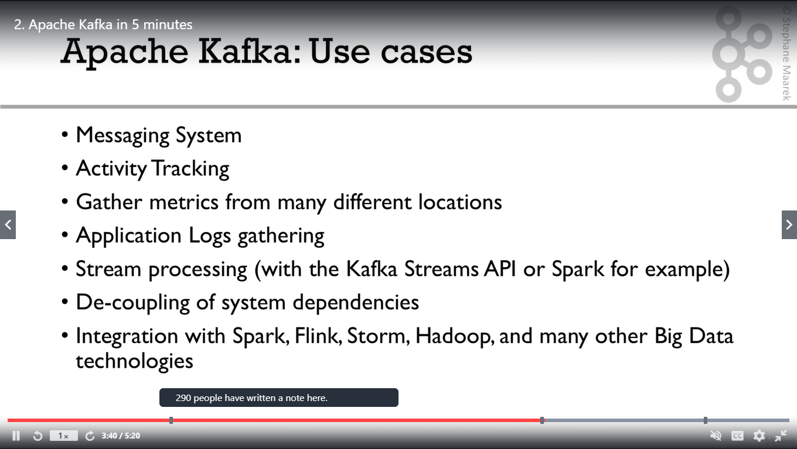

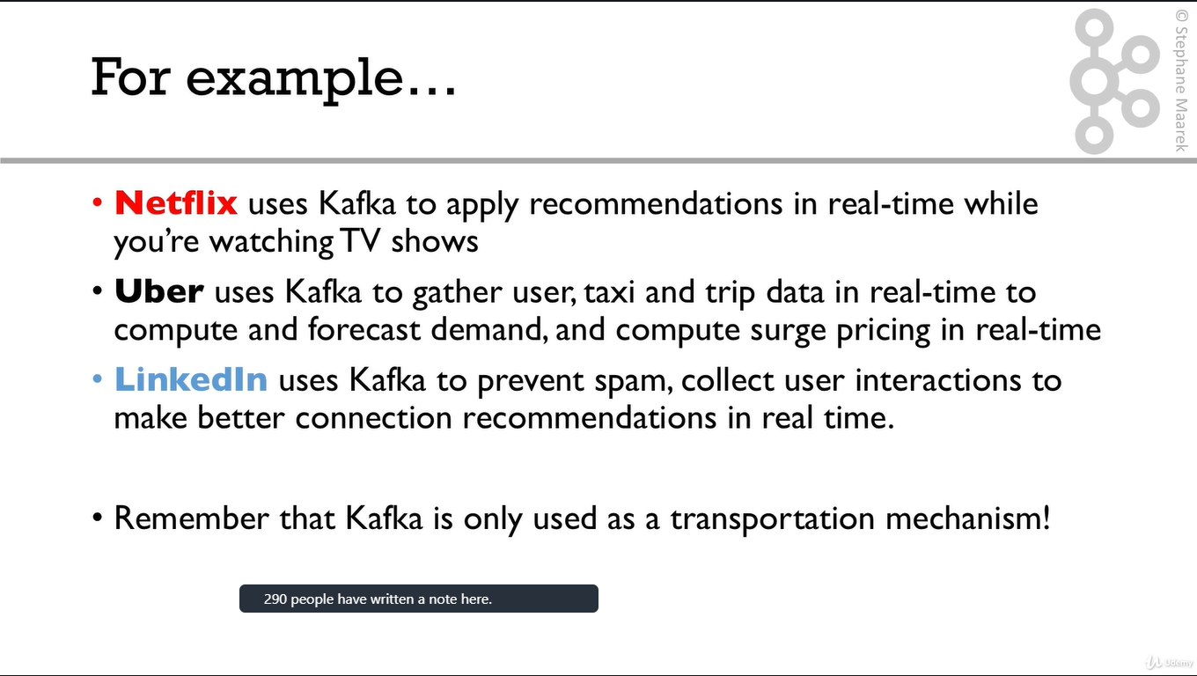

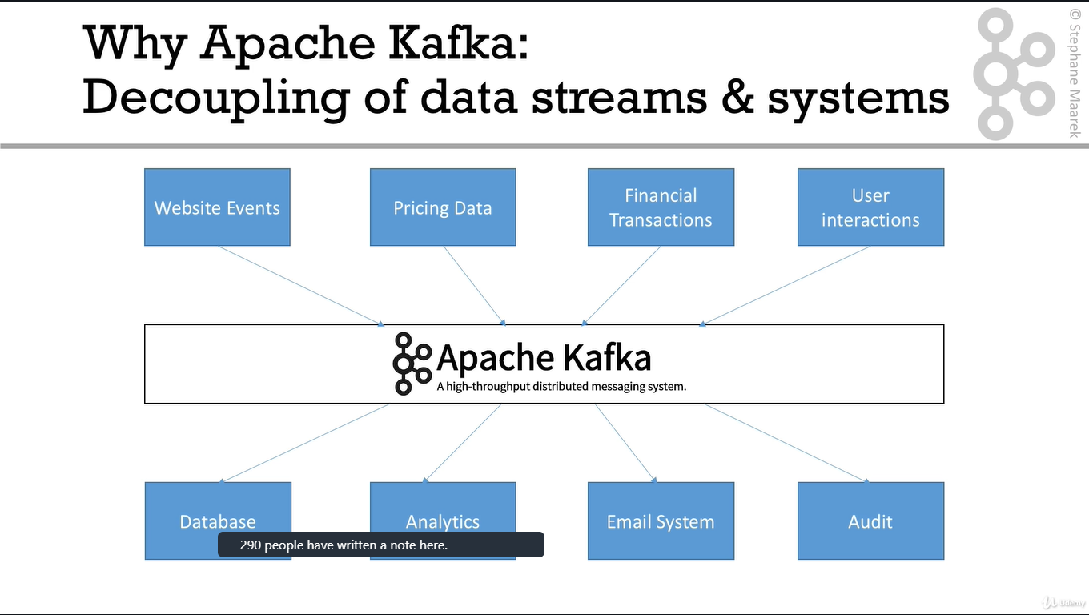

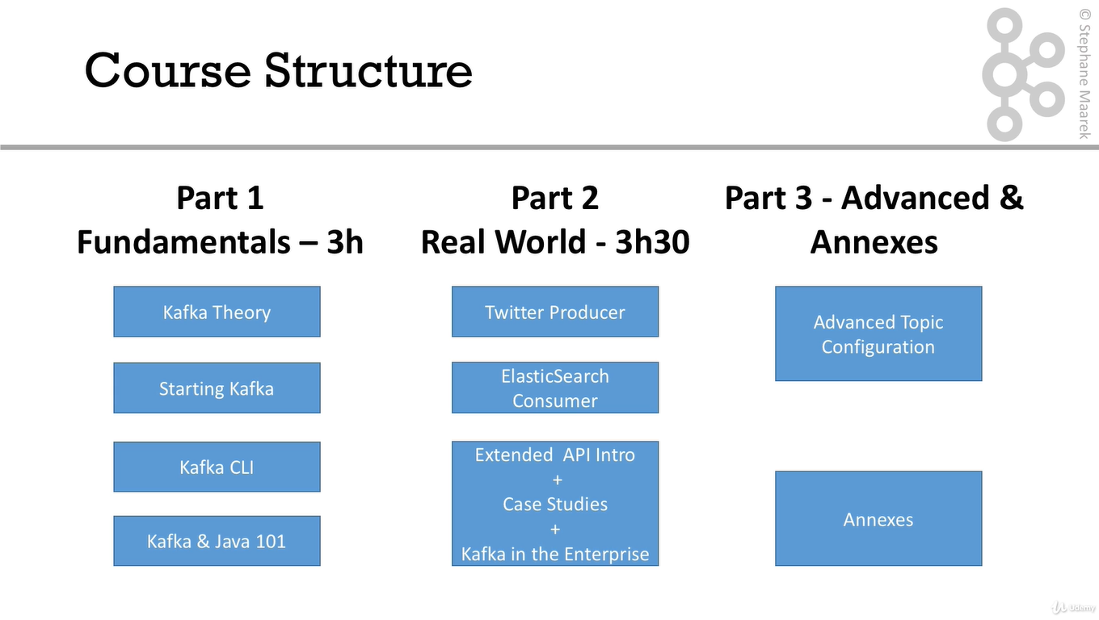

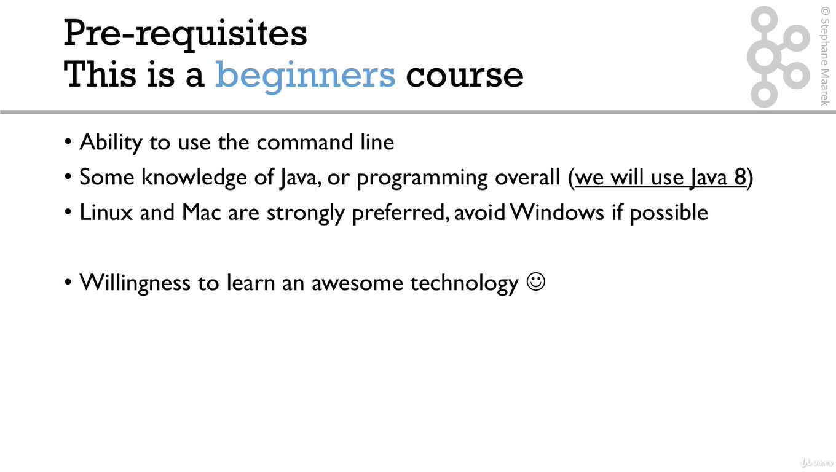

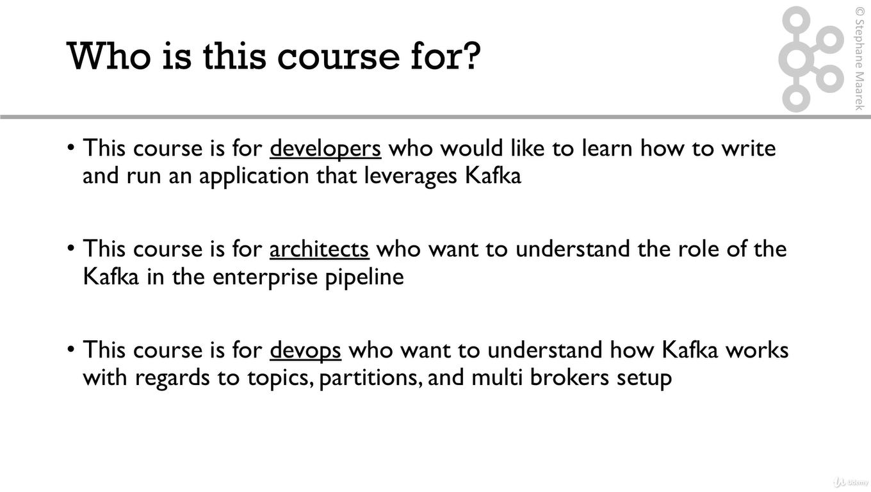

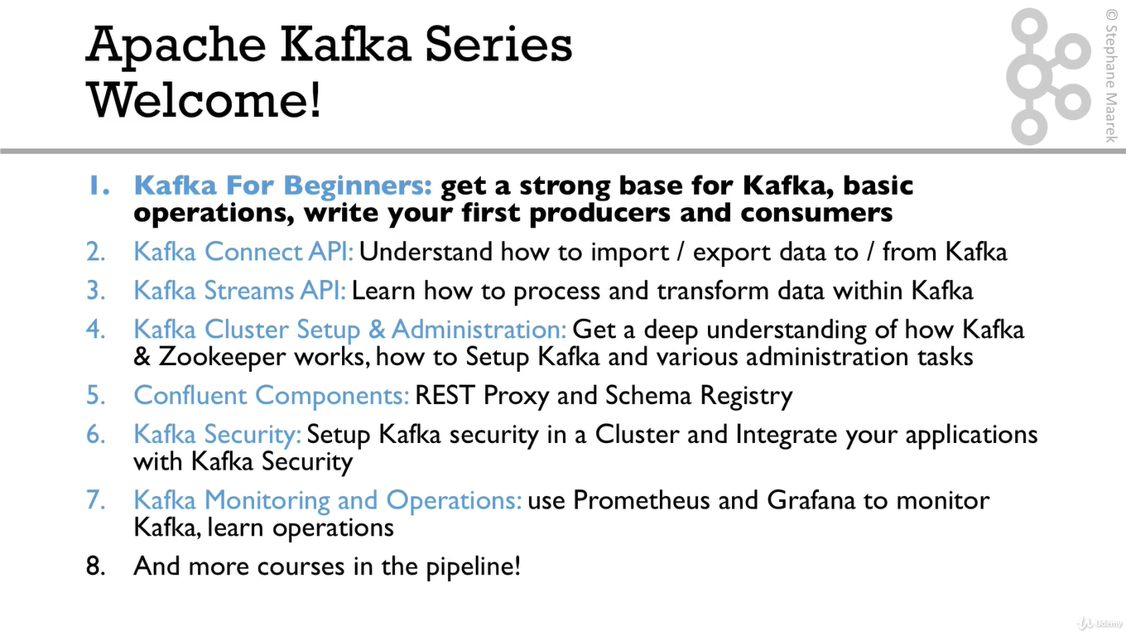

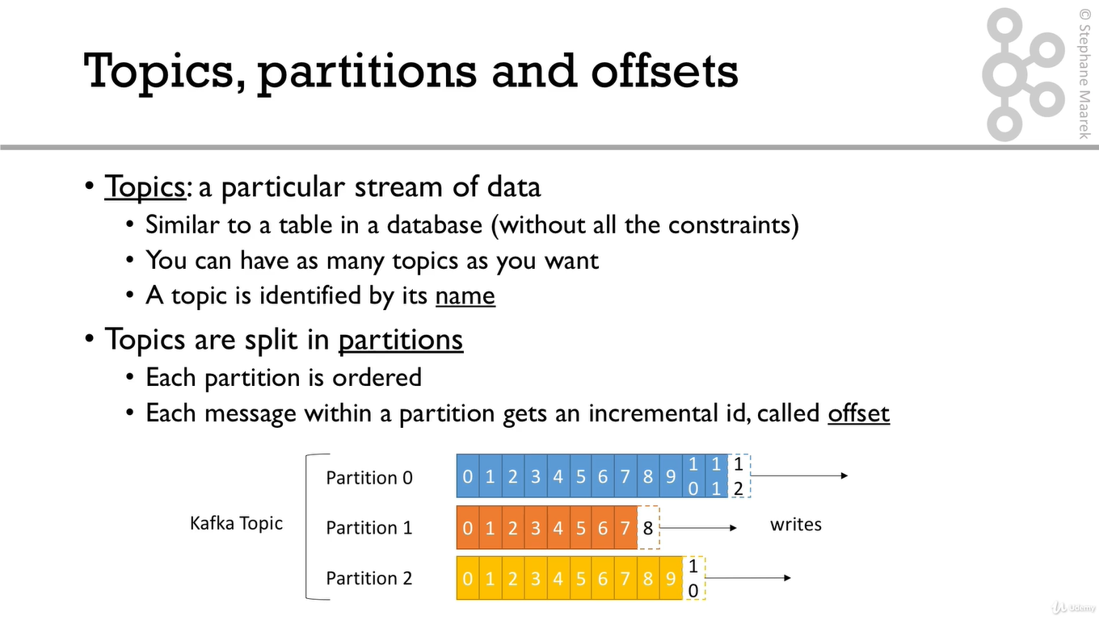

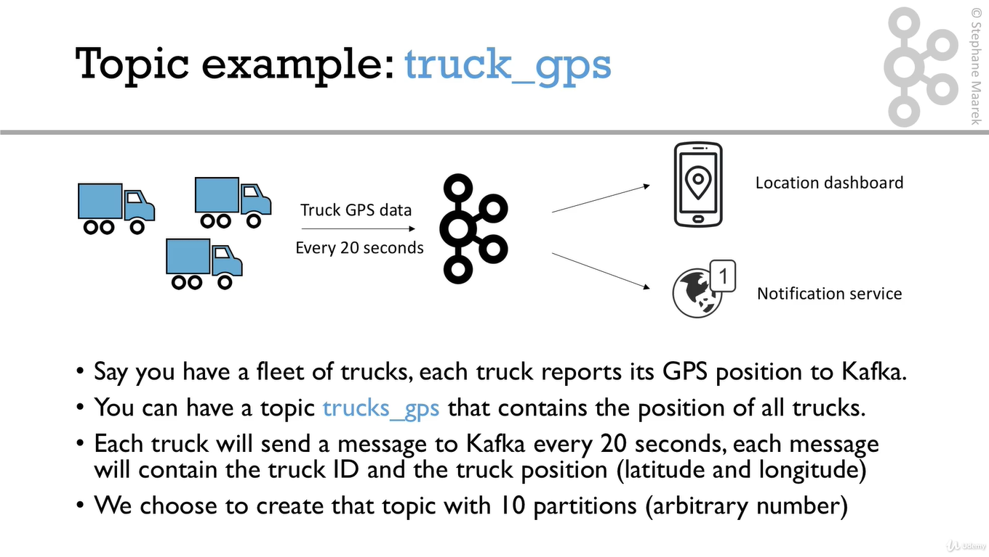

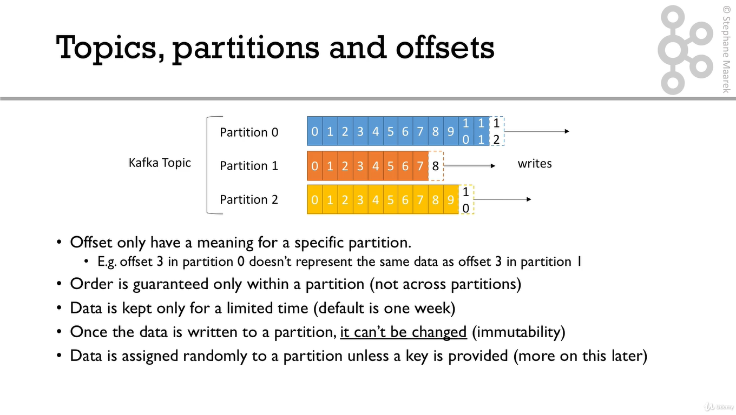

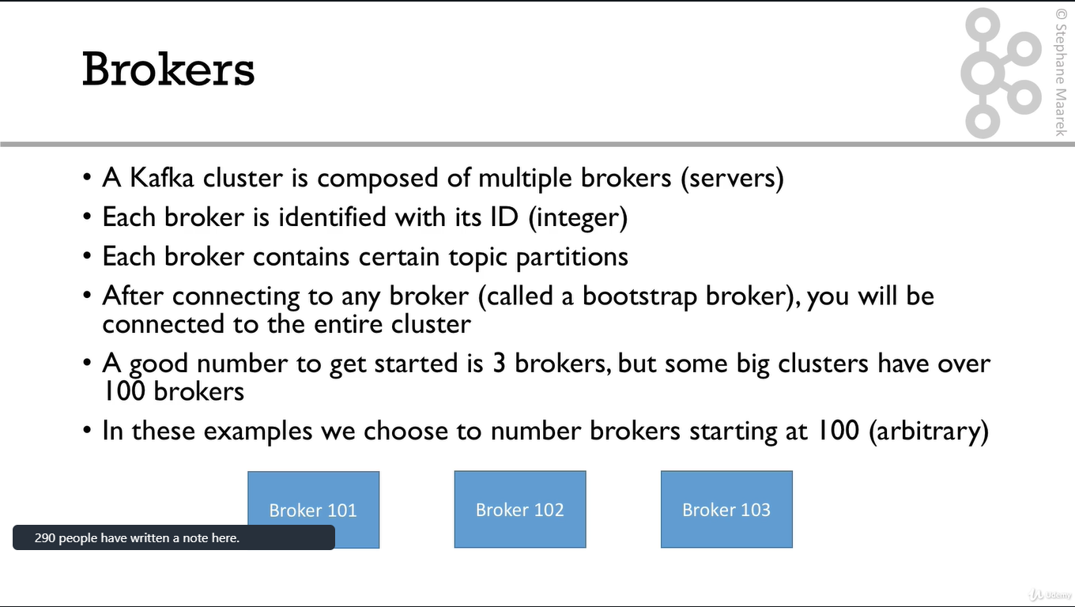

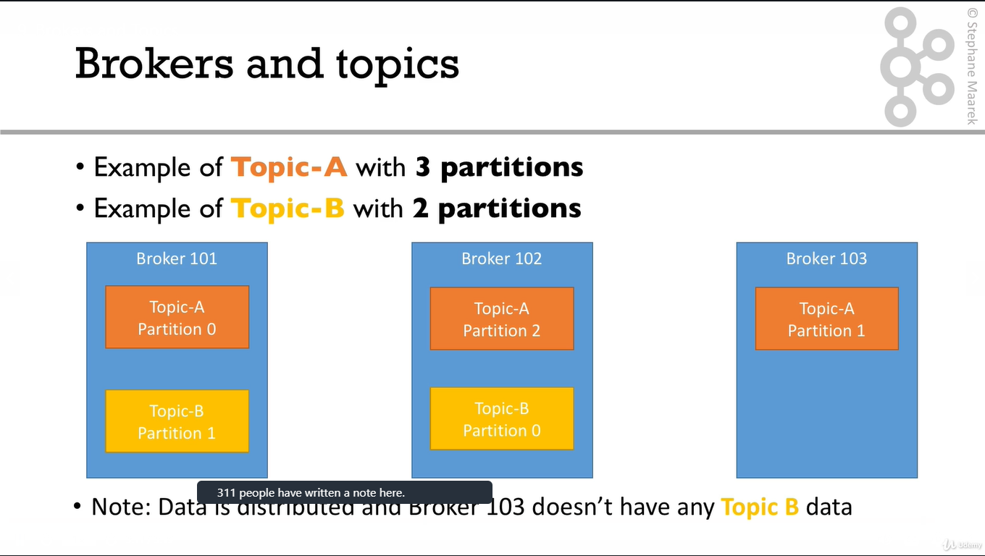

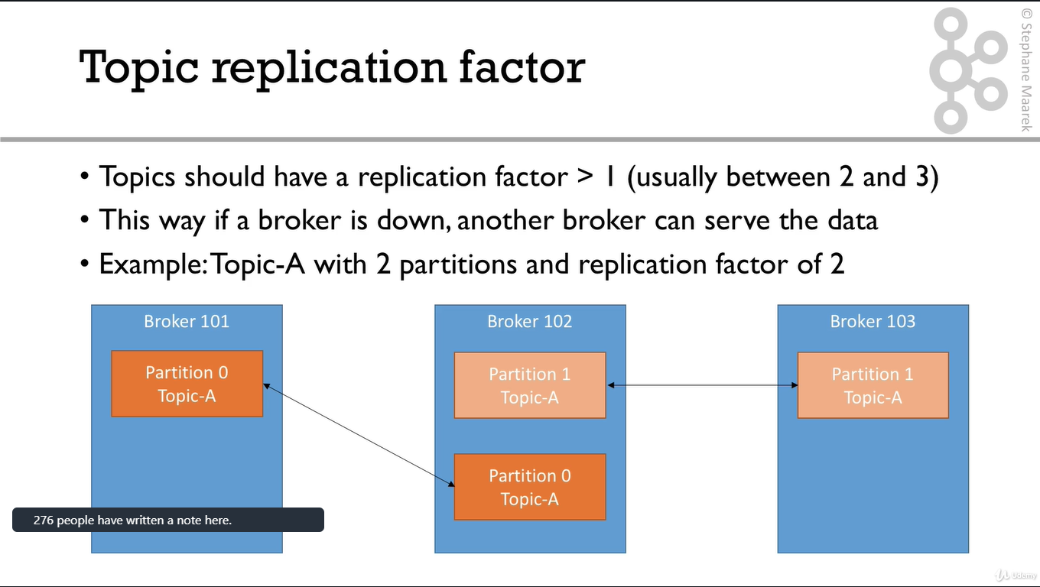

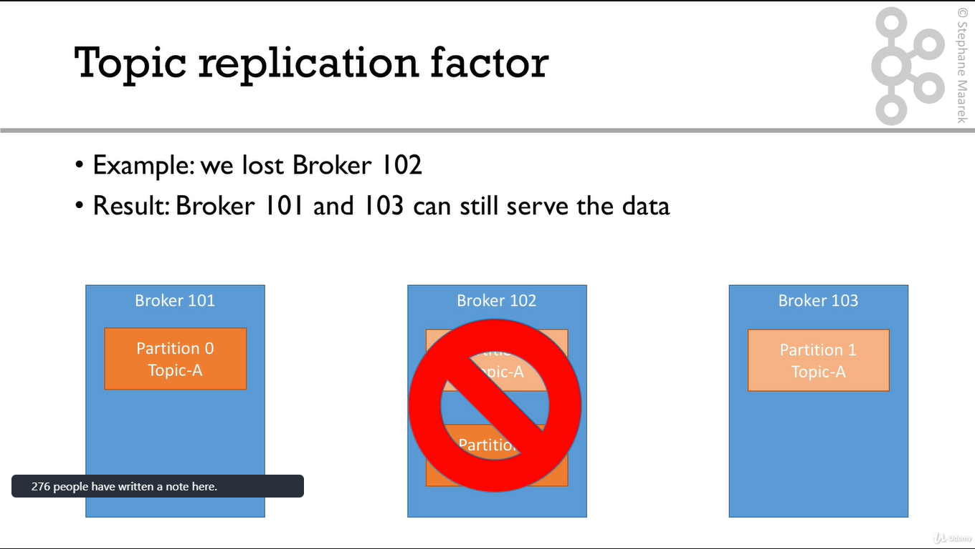

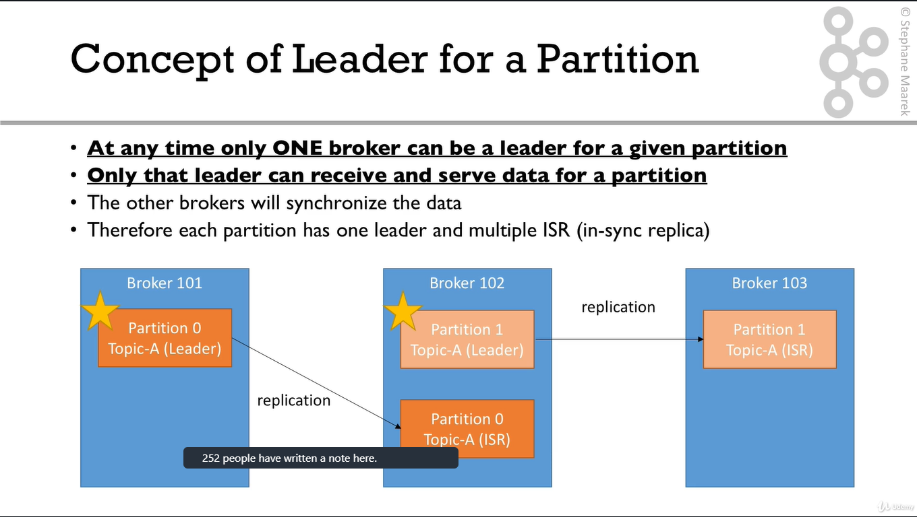

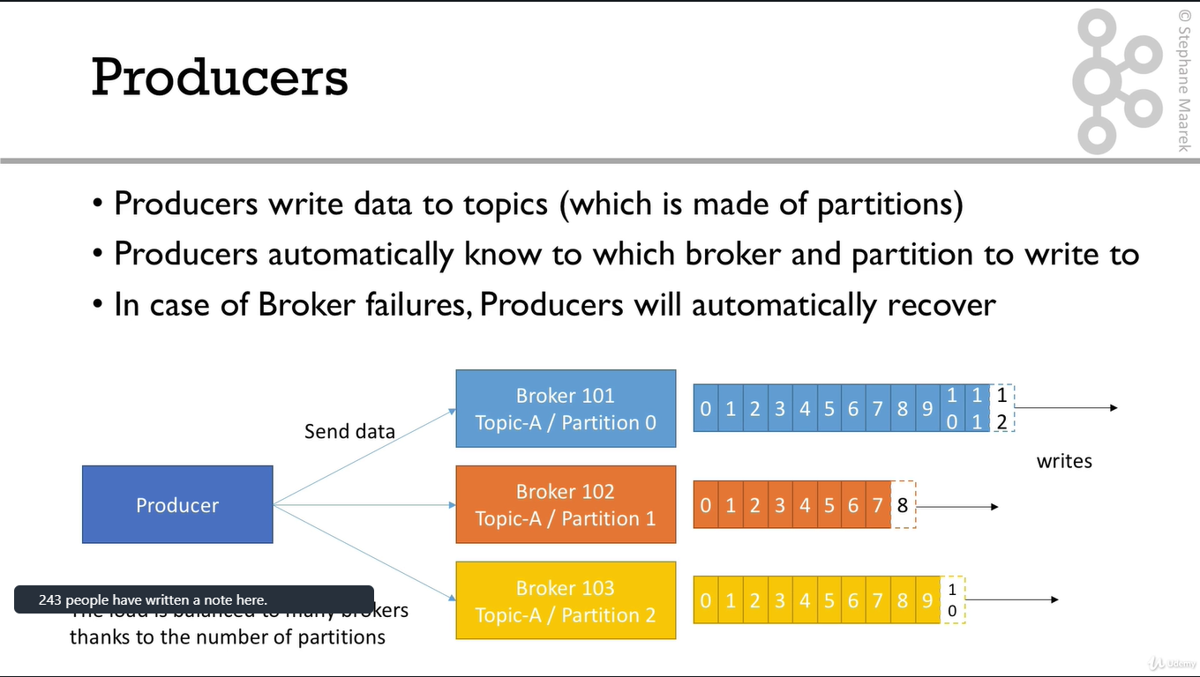

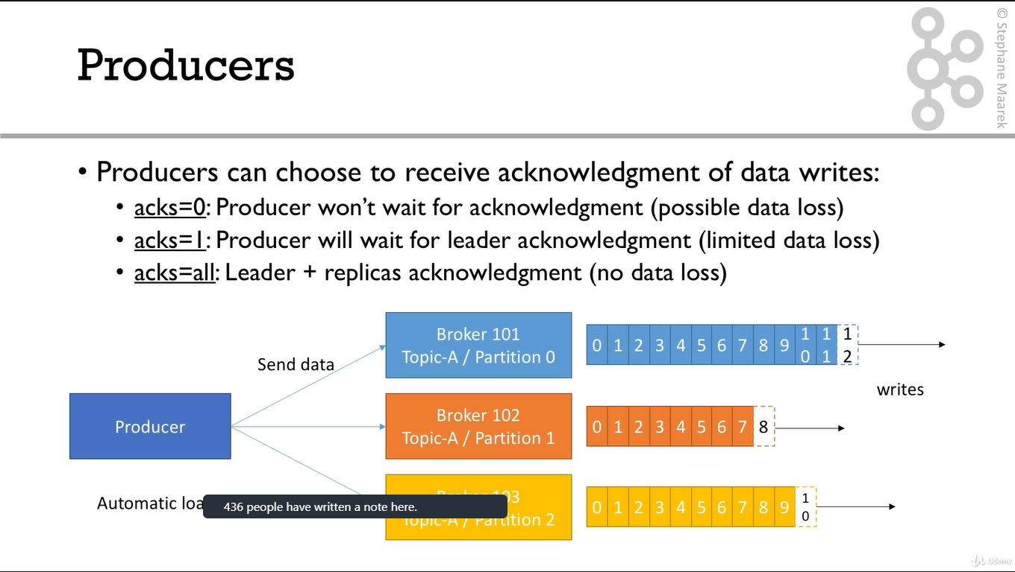

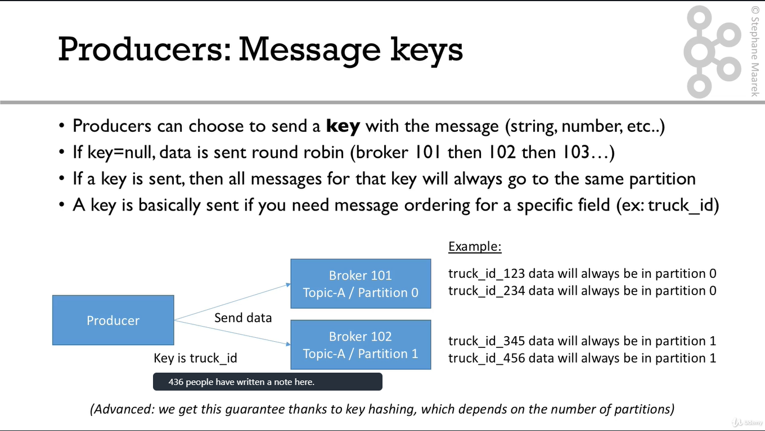

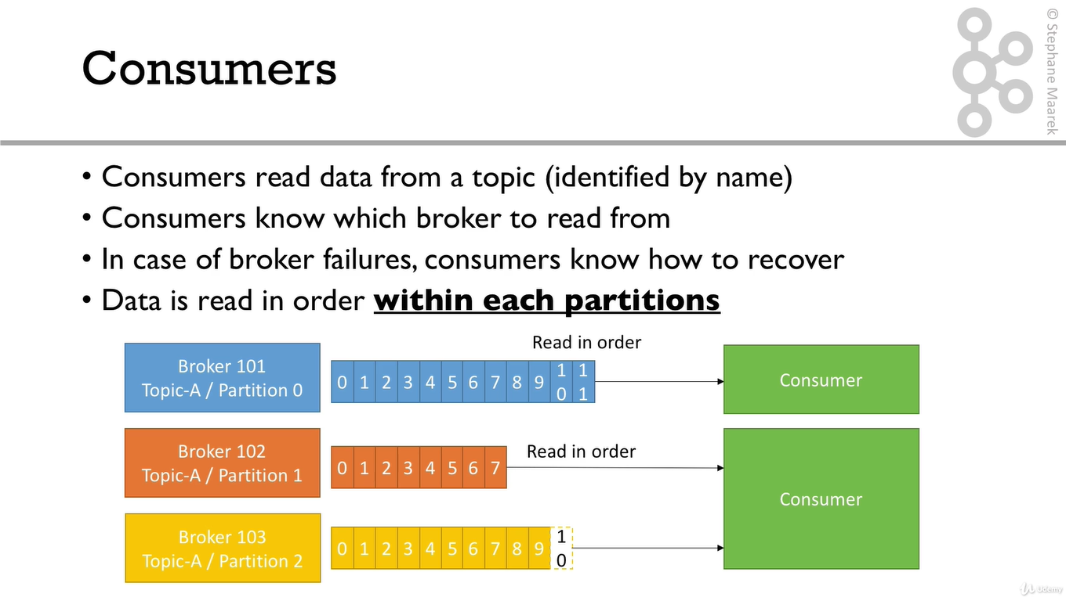

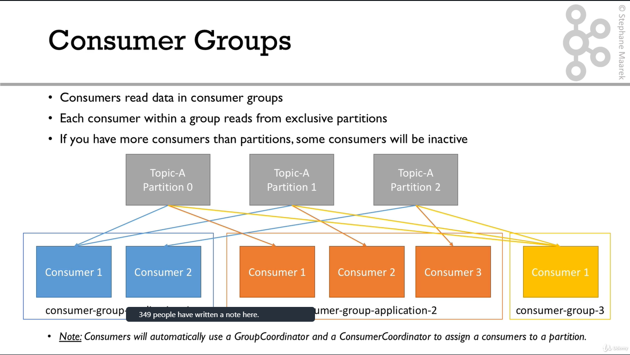

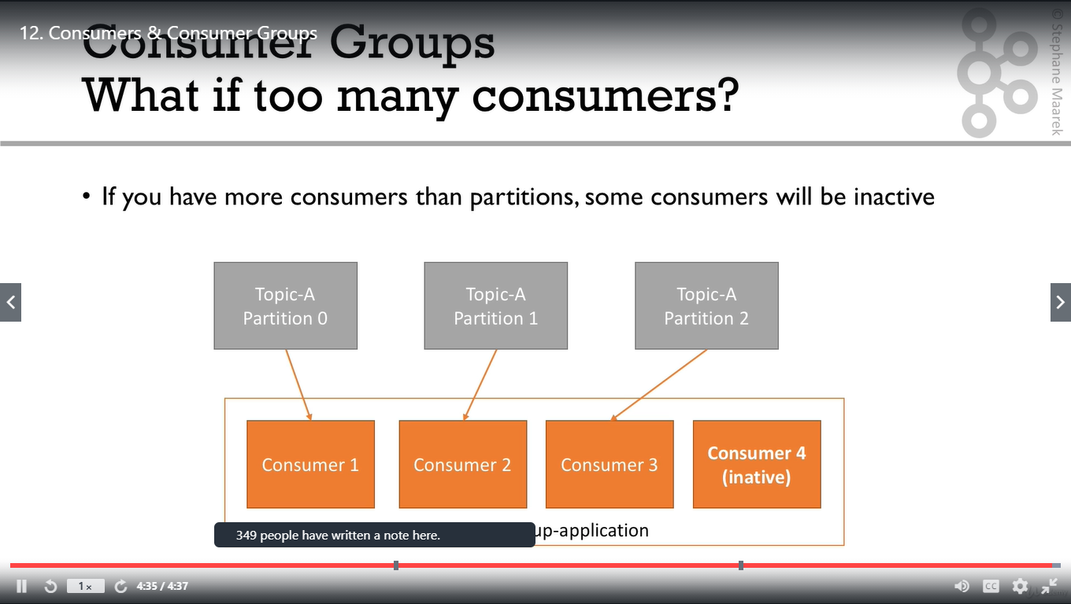

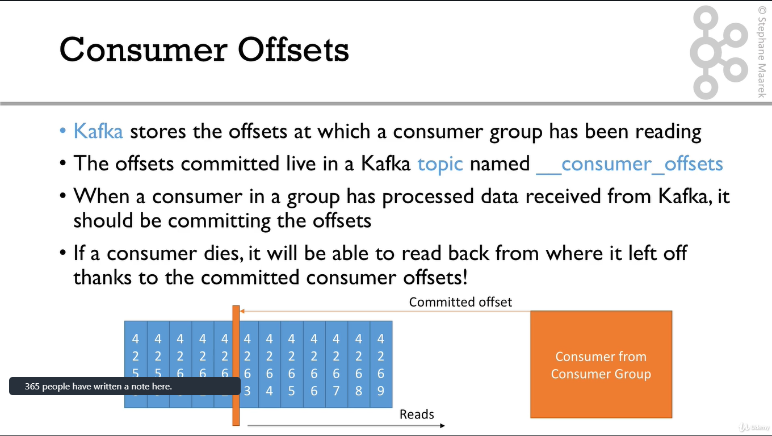

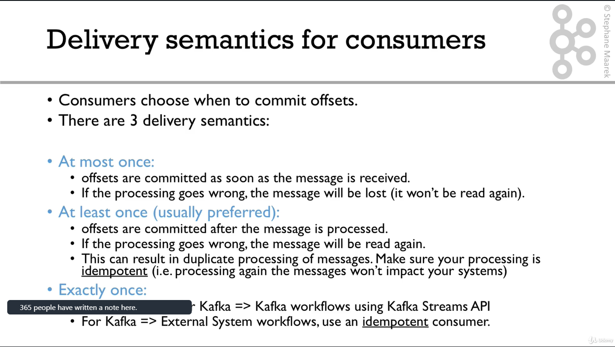

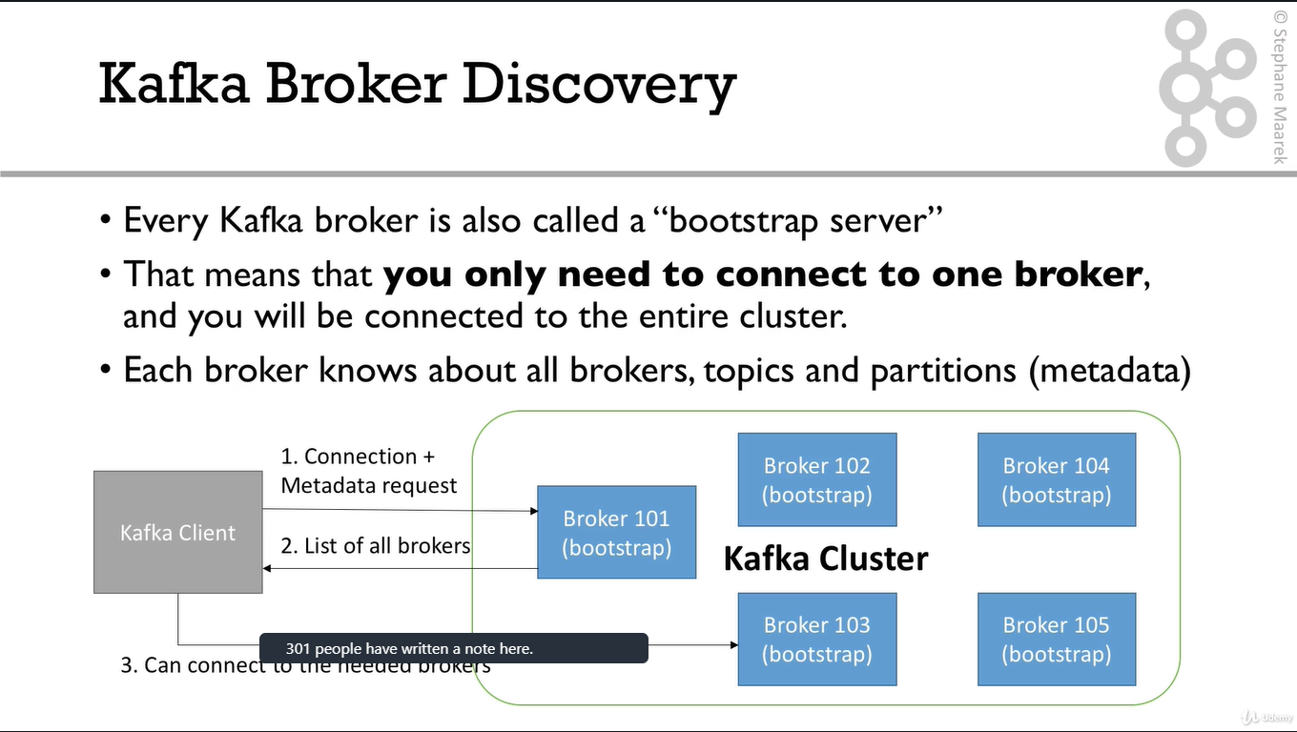

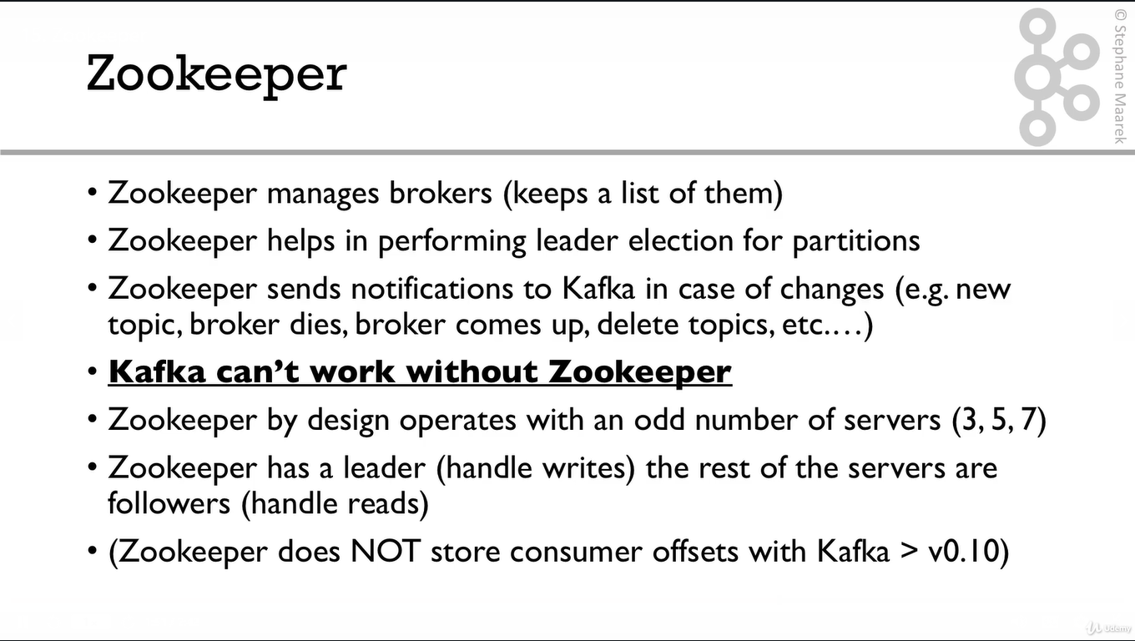

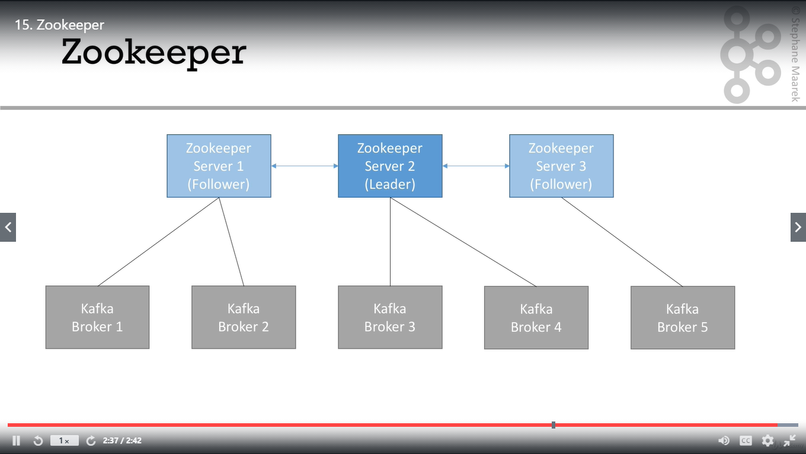

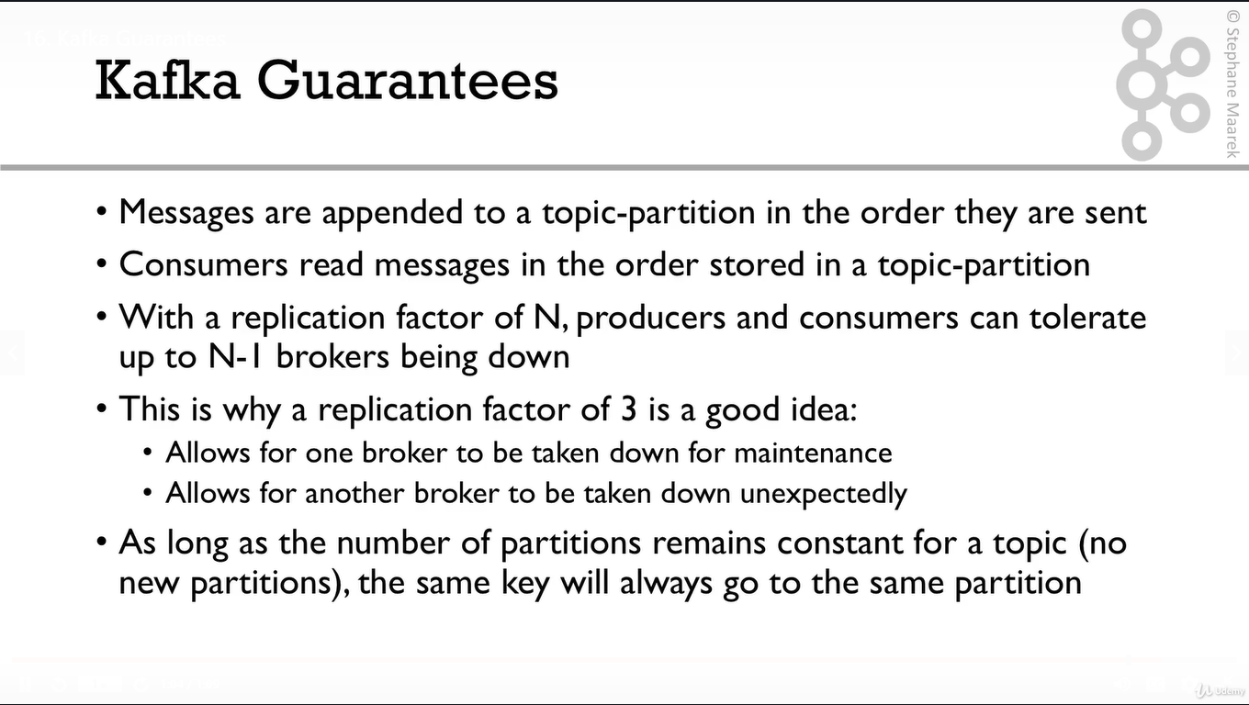

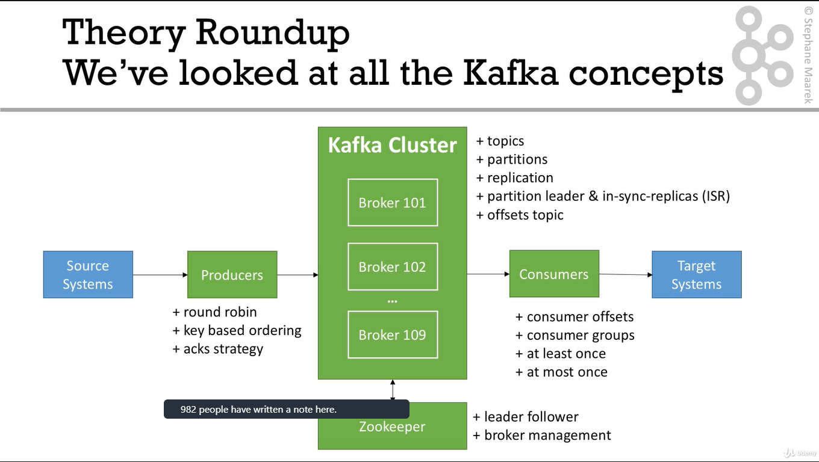

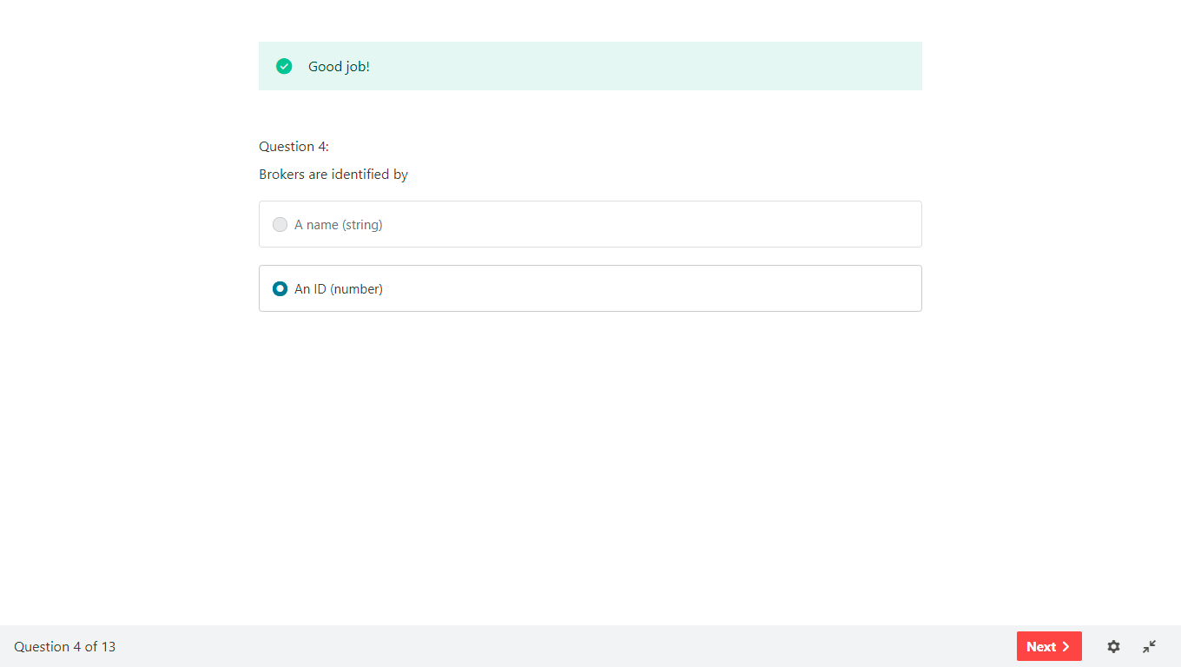

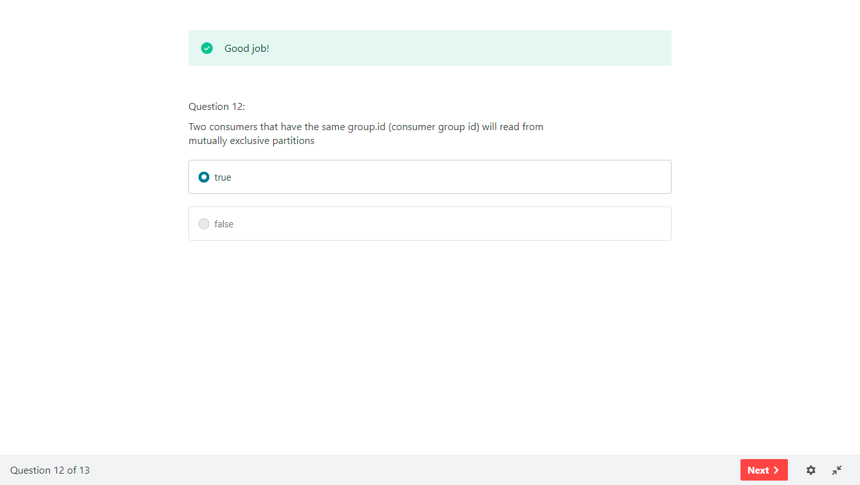

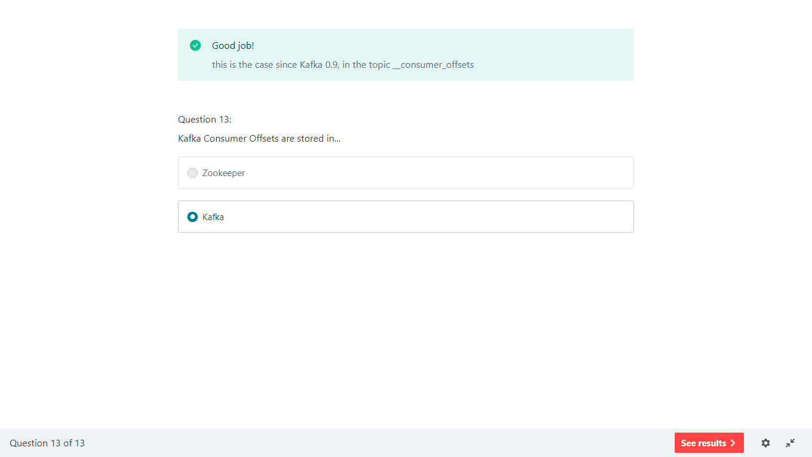

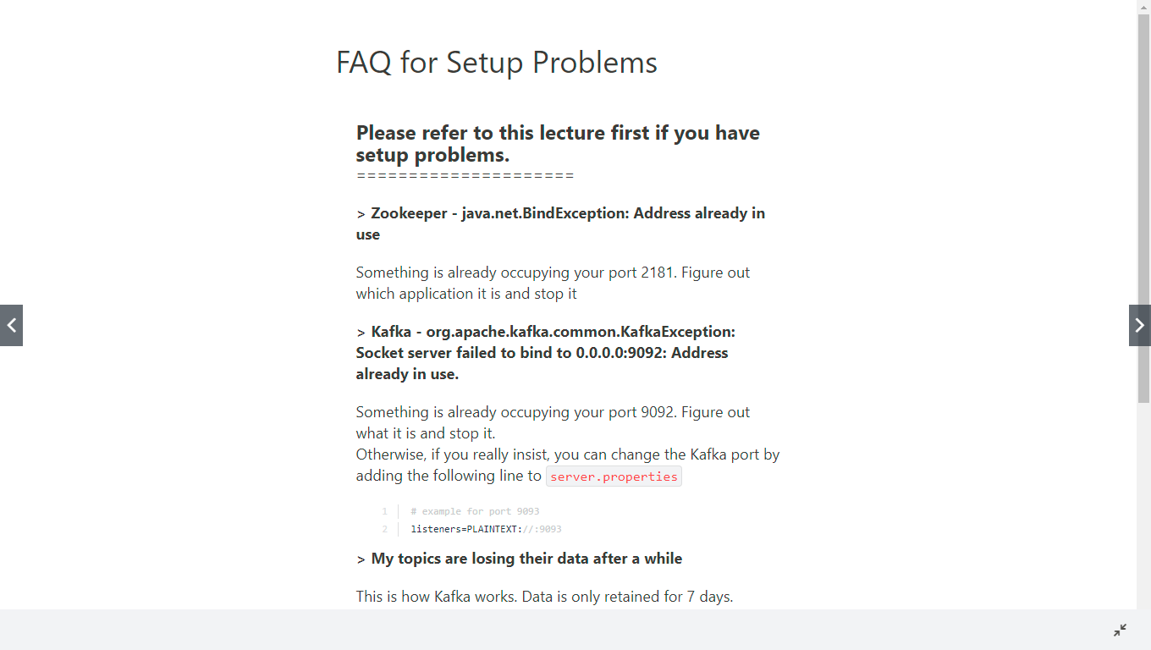

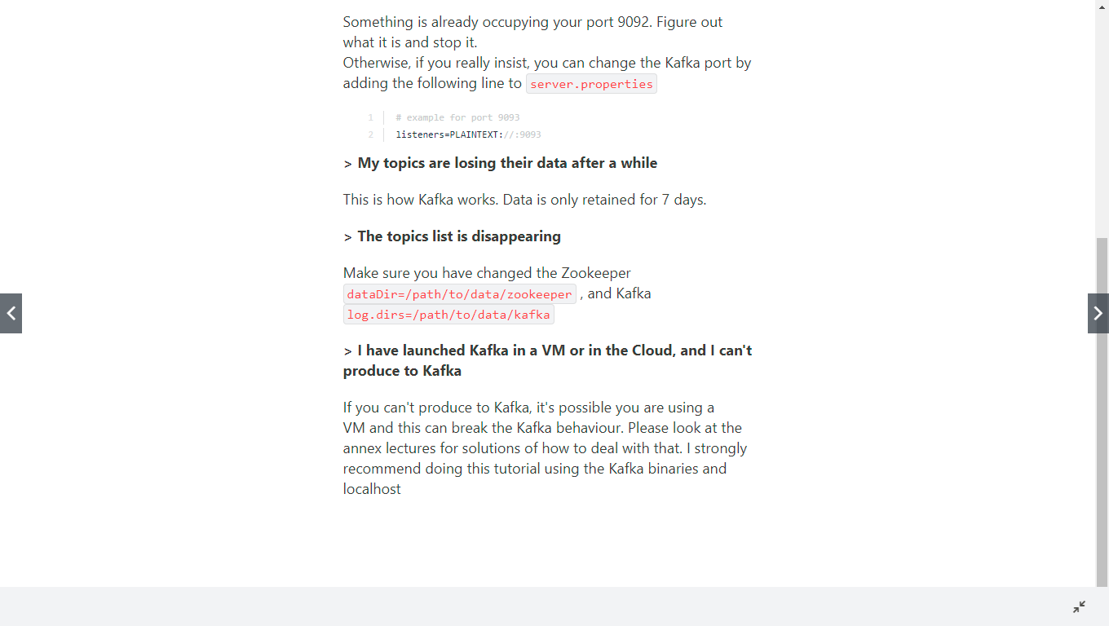

We can install kafka in two ways in Mac.

1. Downloading Kafka binaries then we can run kafka *.sh files
   1. We need to set the path to call kafka*.sh from anywhere
2. Brewing from mac cmd then we can kafka* without .sh files
   1. Do not need to set the path for the same.

Next few slides talks about this.

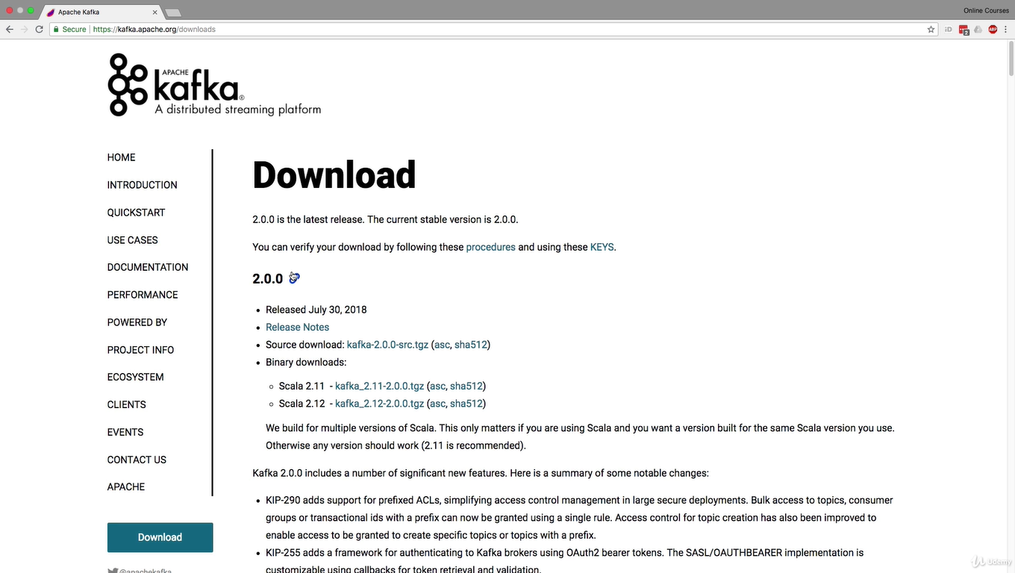

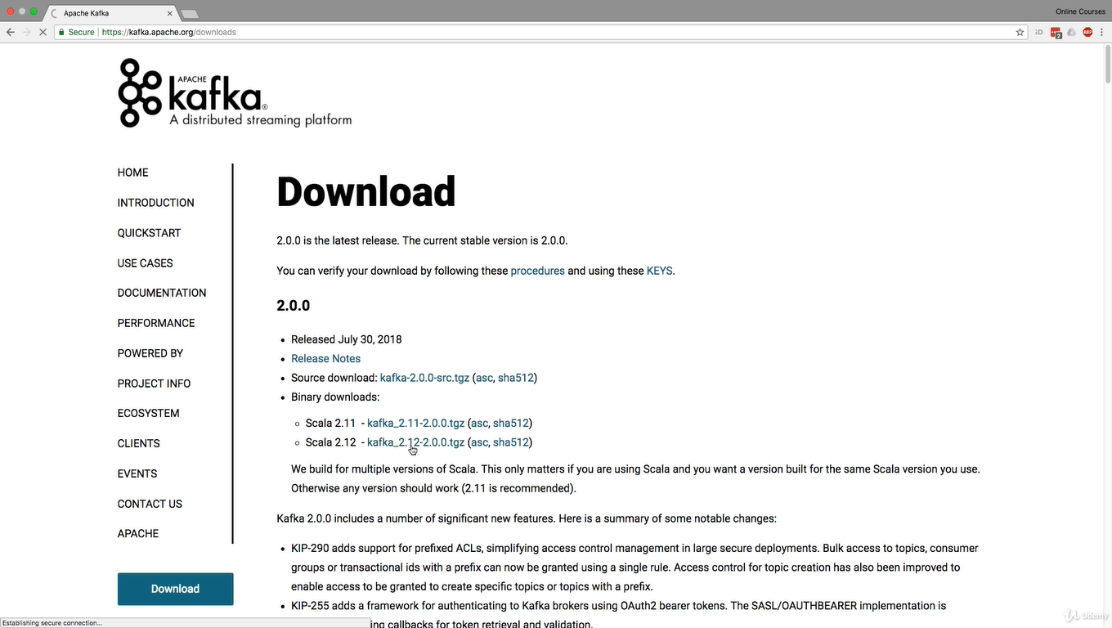

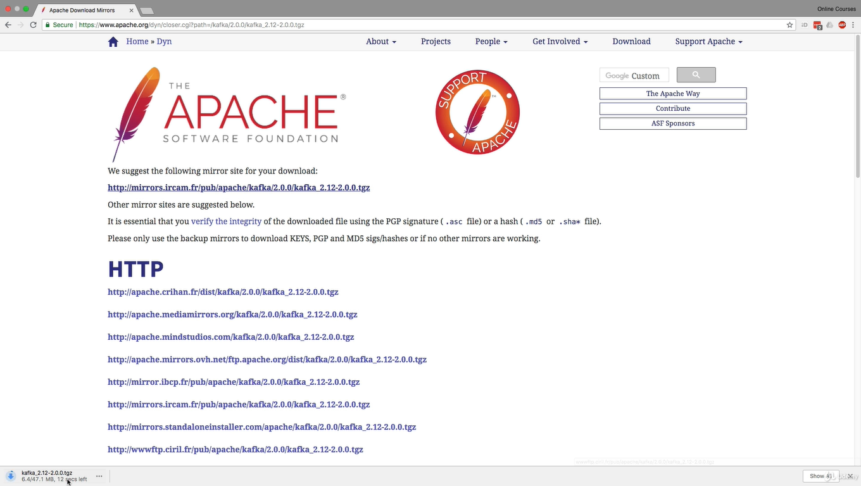

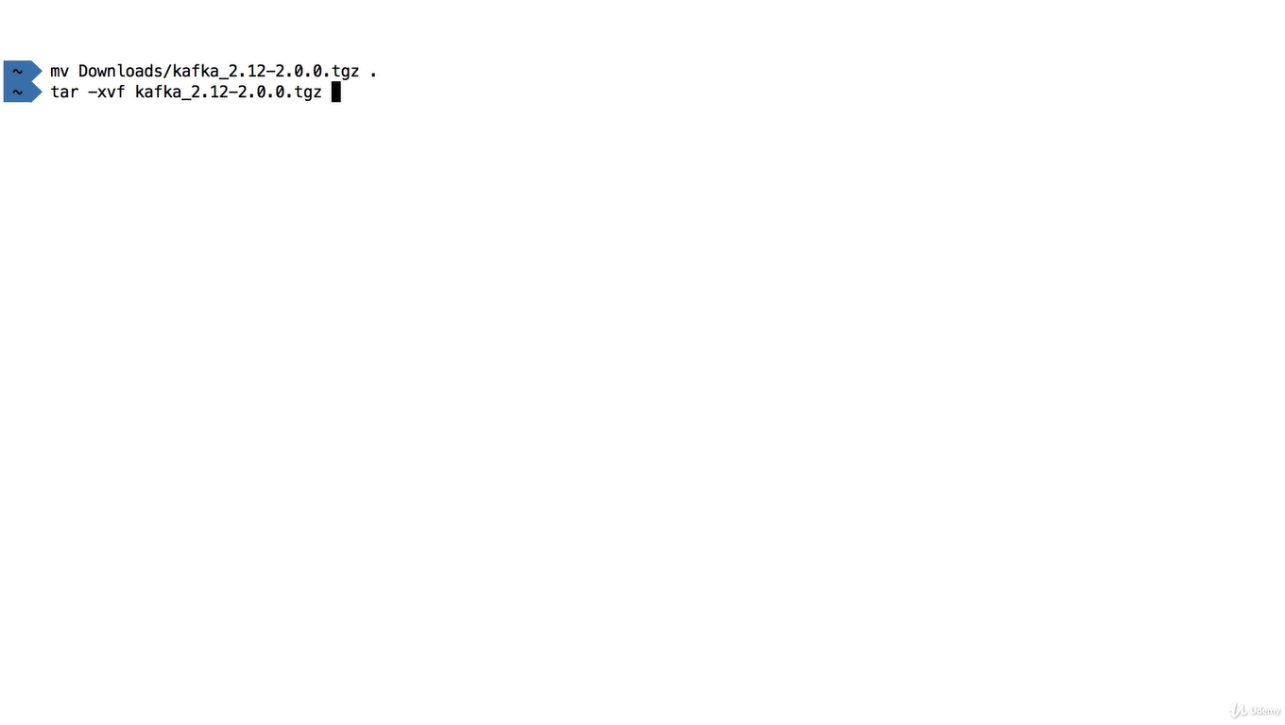

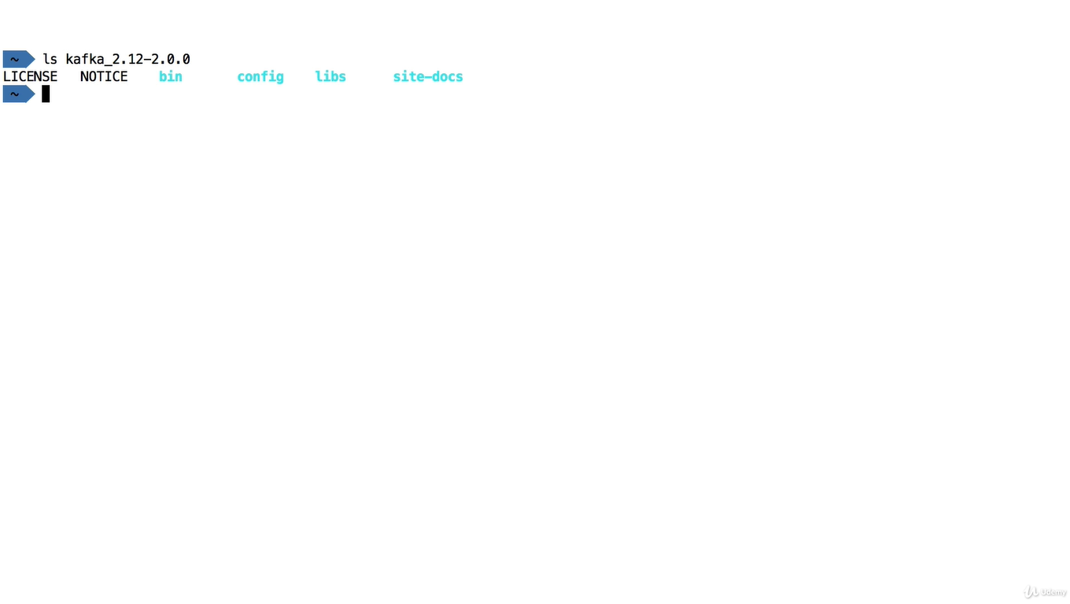

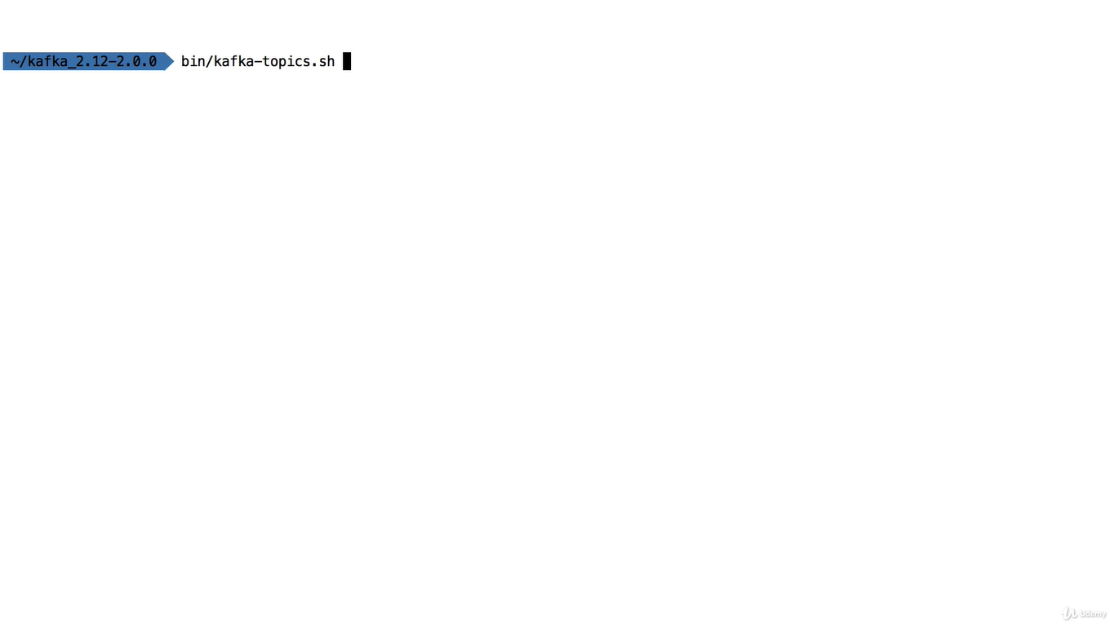

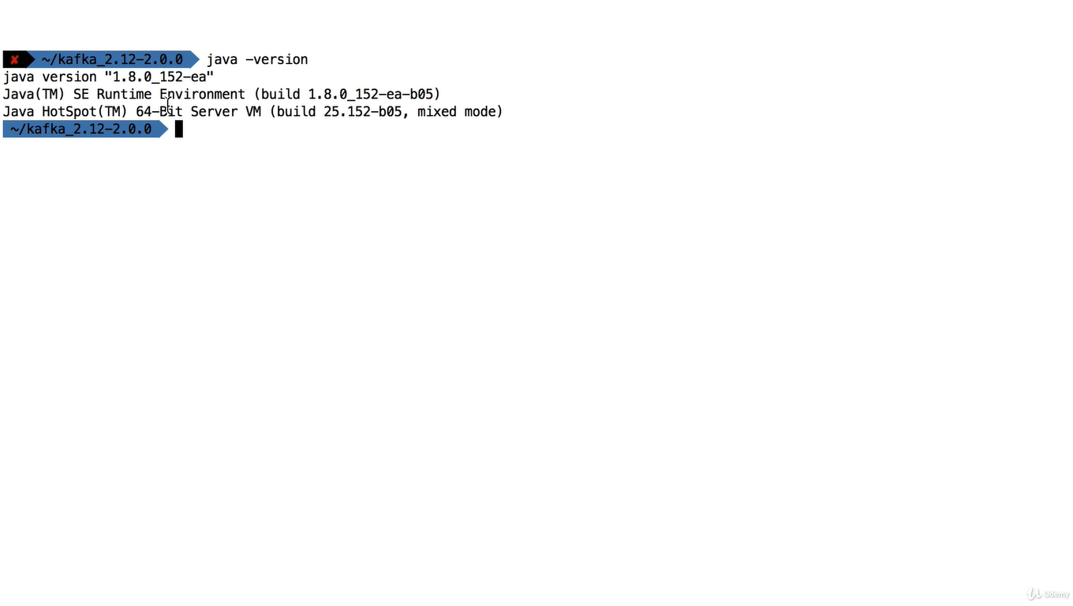

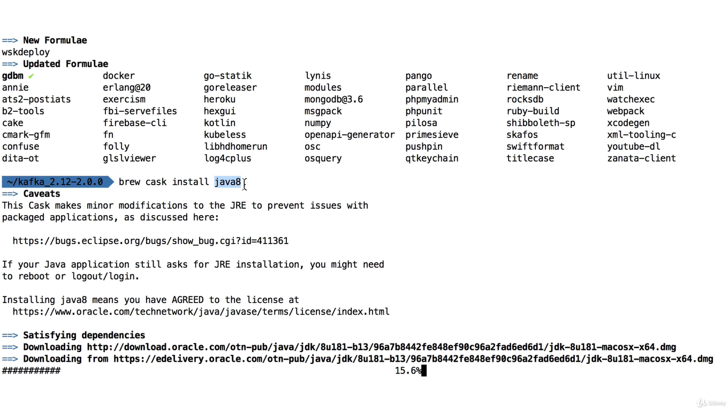

Setting the path

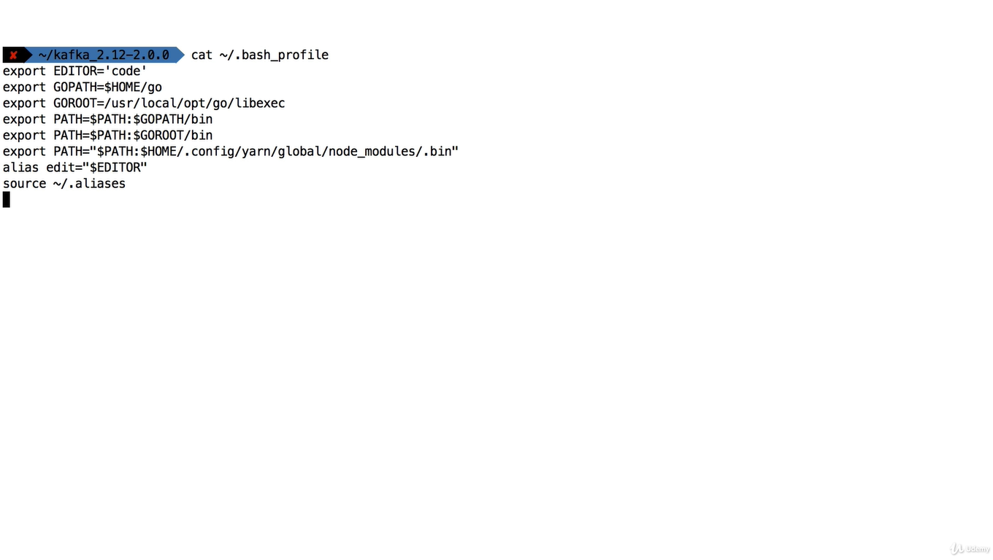

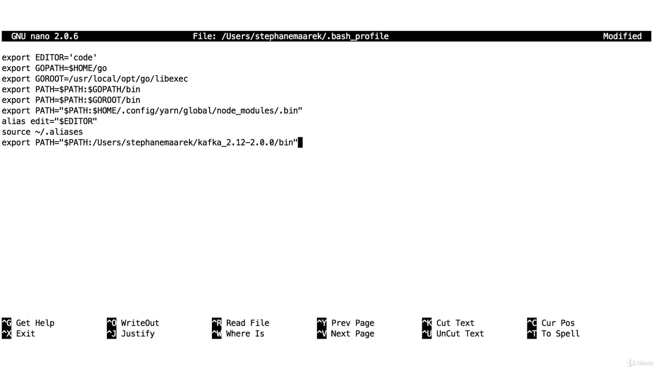

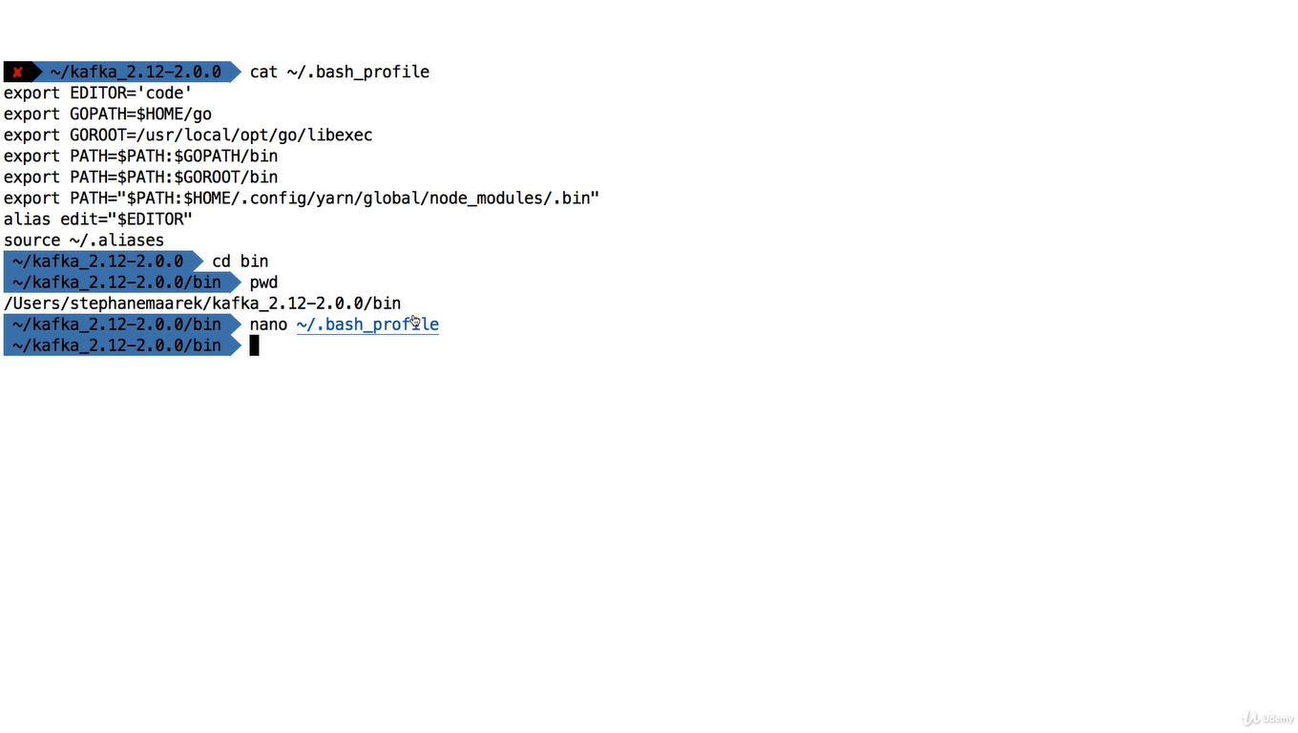

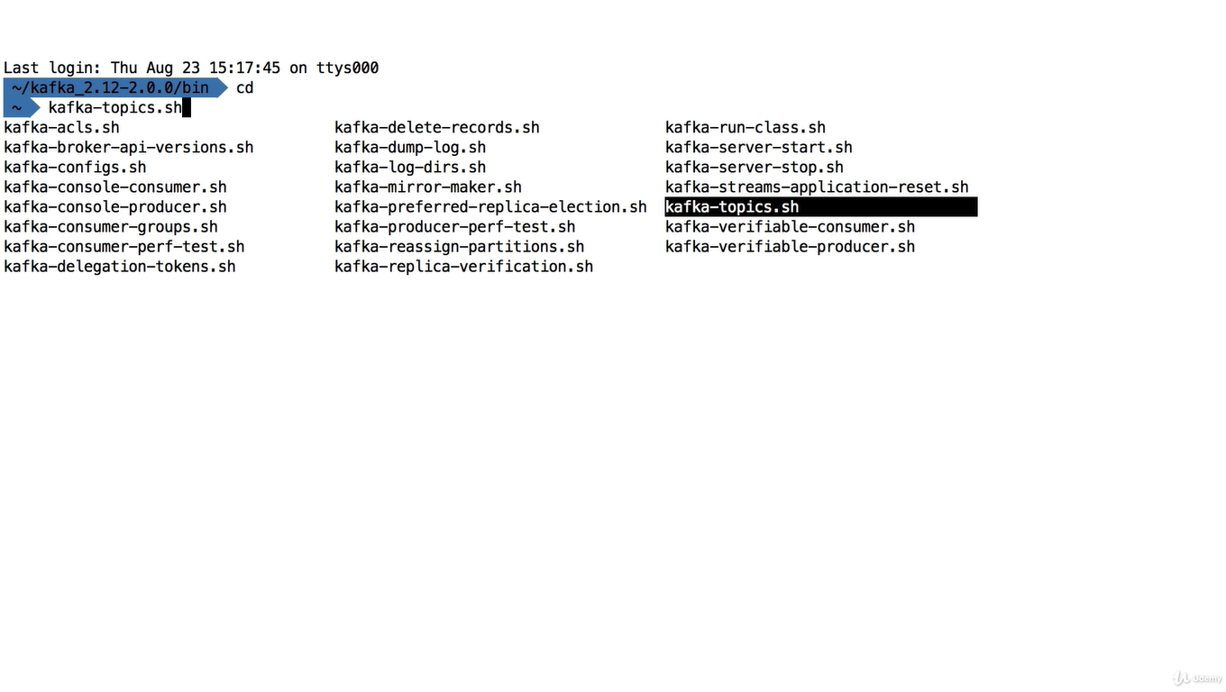

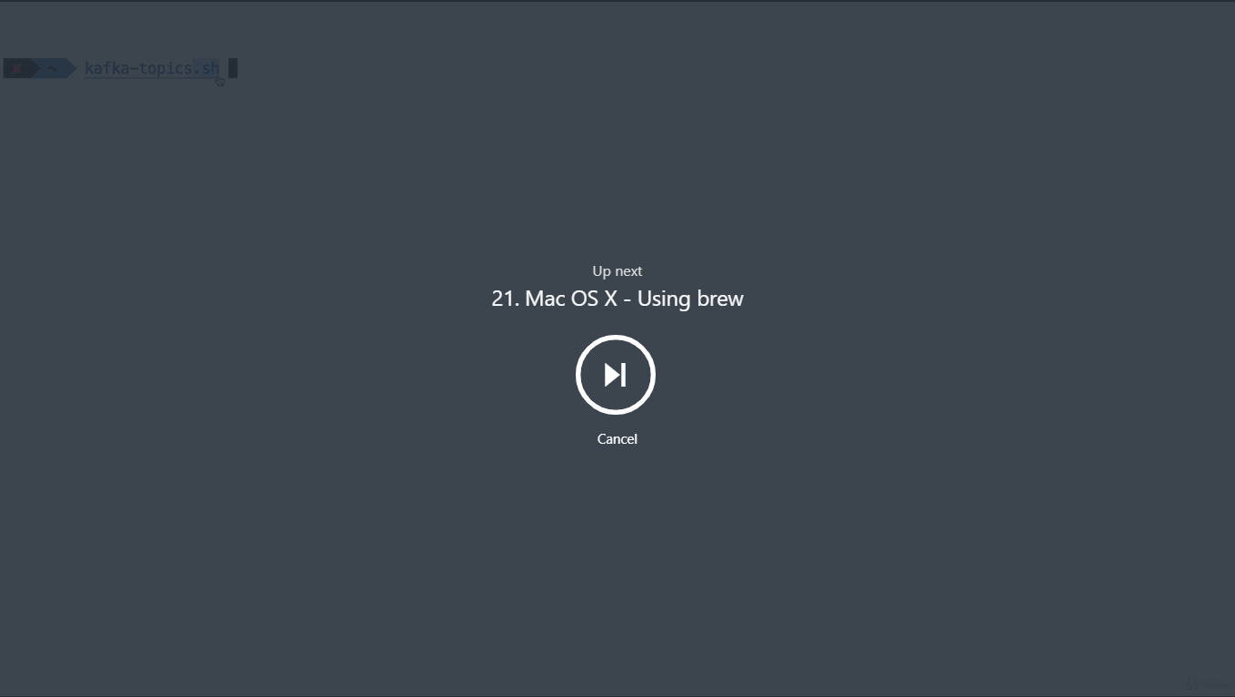

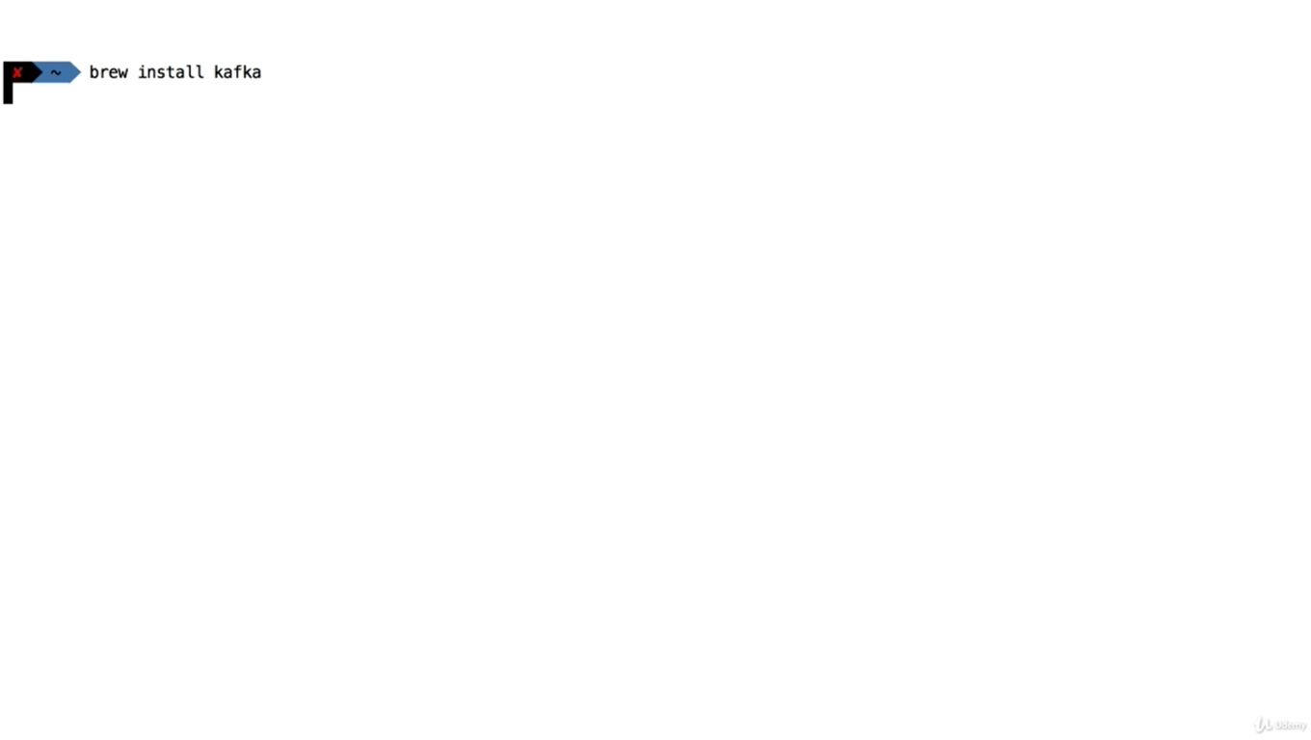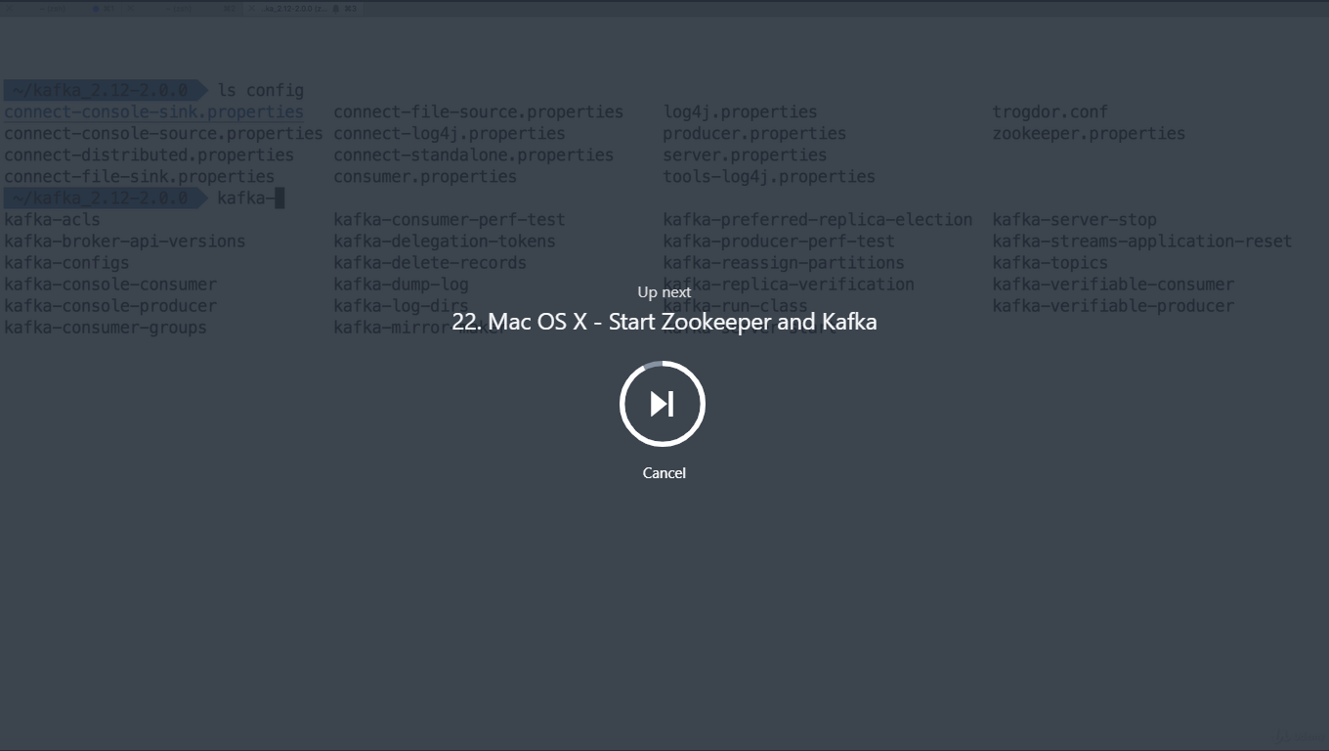

Here we need to start Zookeeper first then we need to start kafka

One way to start zookeeper

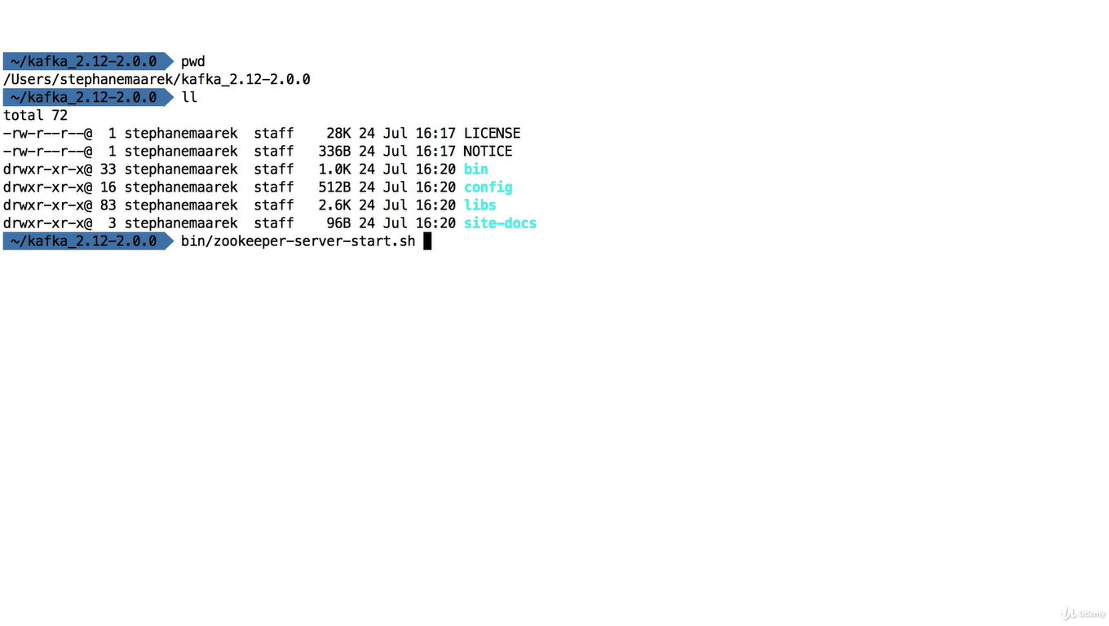

Other way we can do as follow

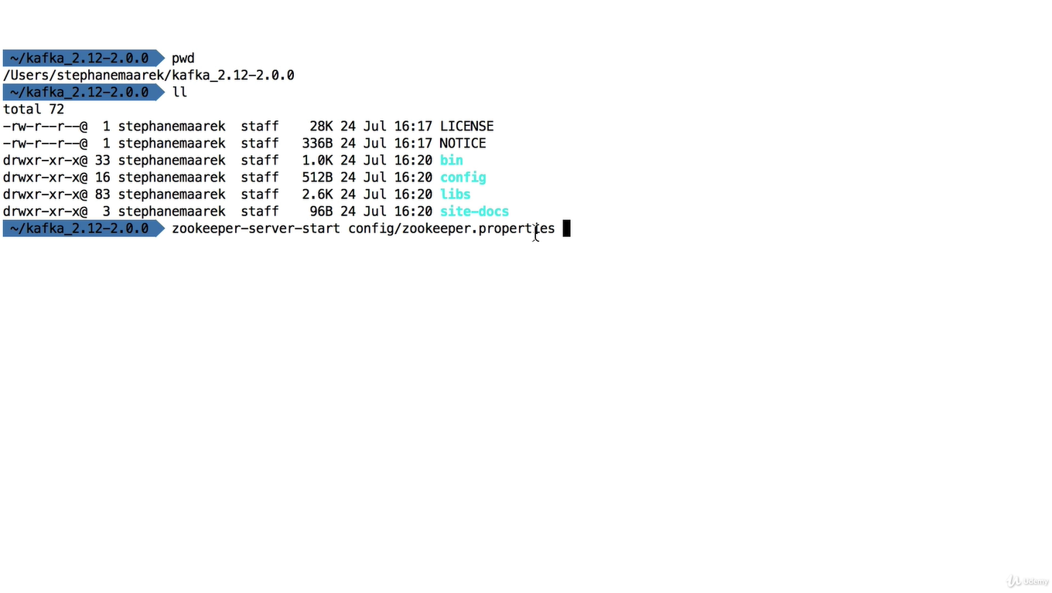

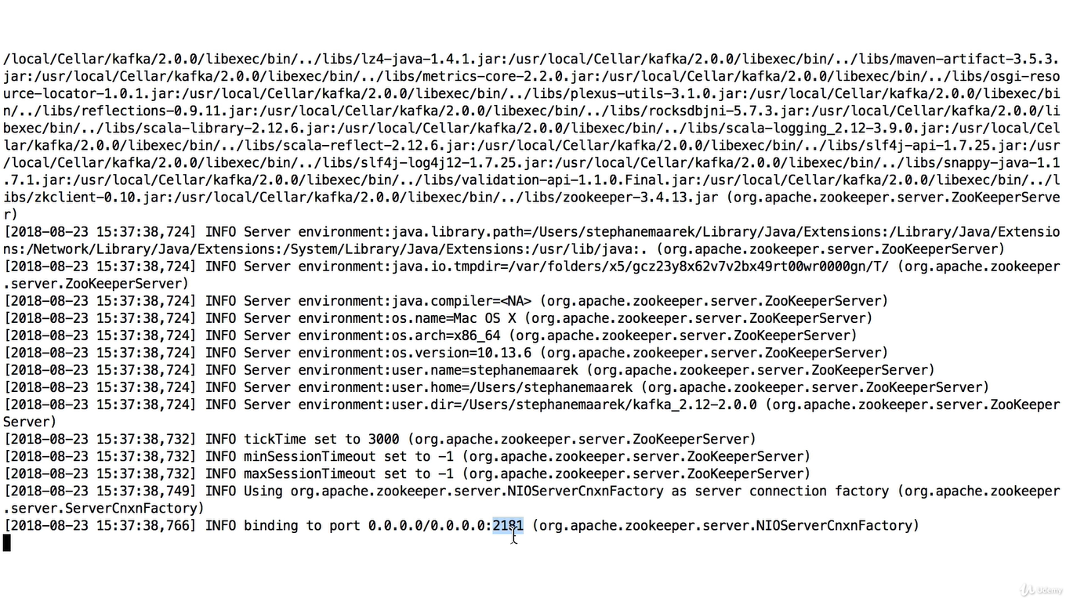

We have to keep zookeeper running

To see zookeeper properties we can do as below

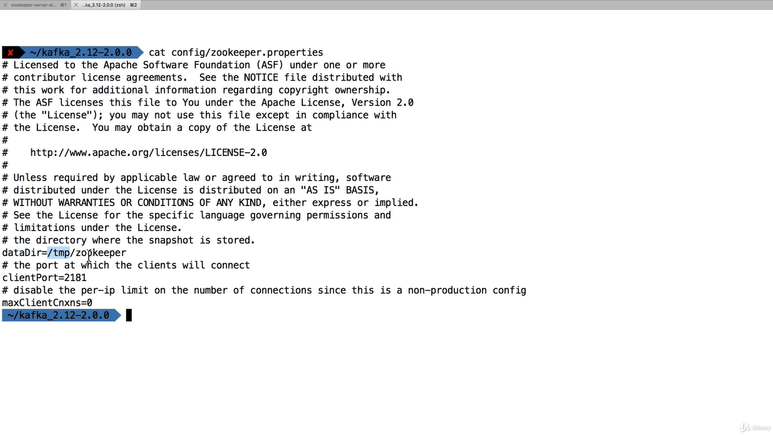

We are going to replace dataDir now

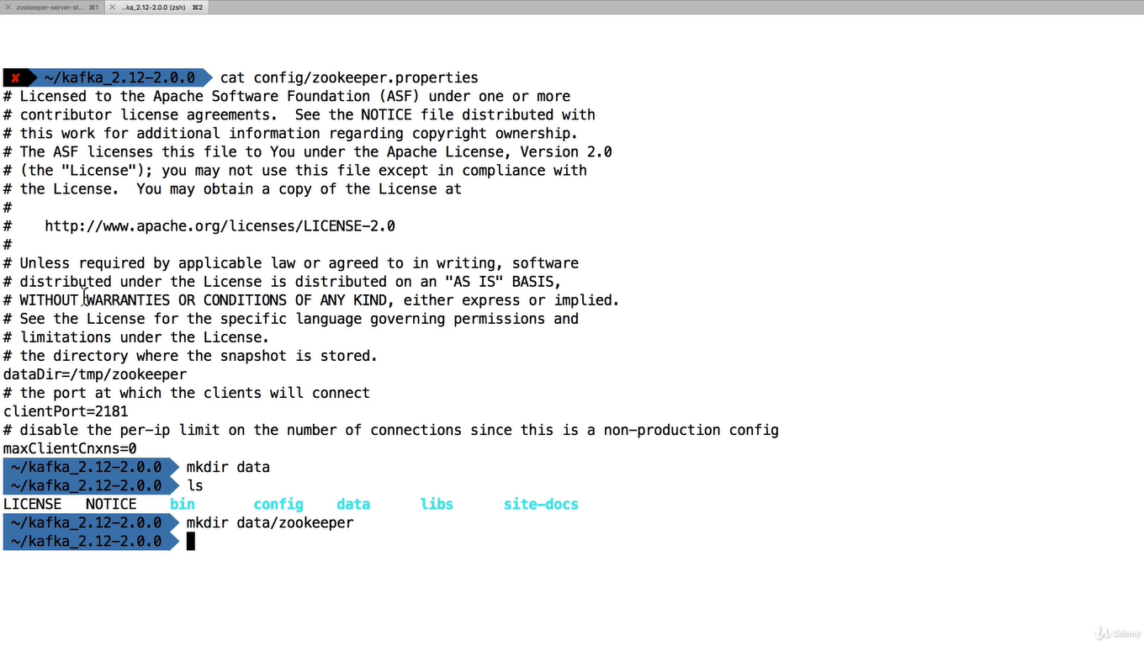

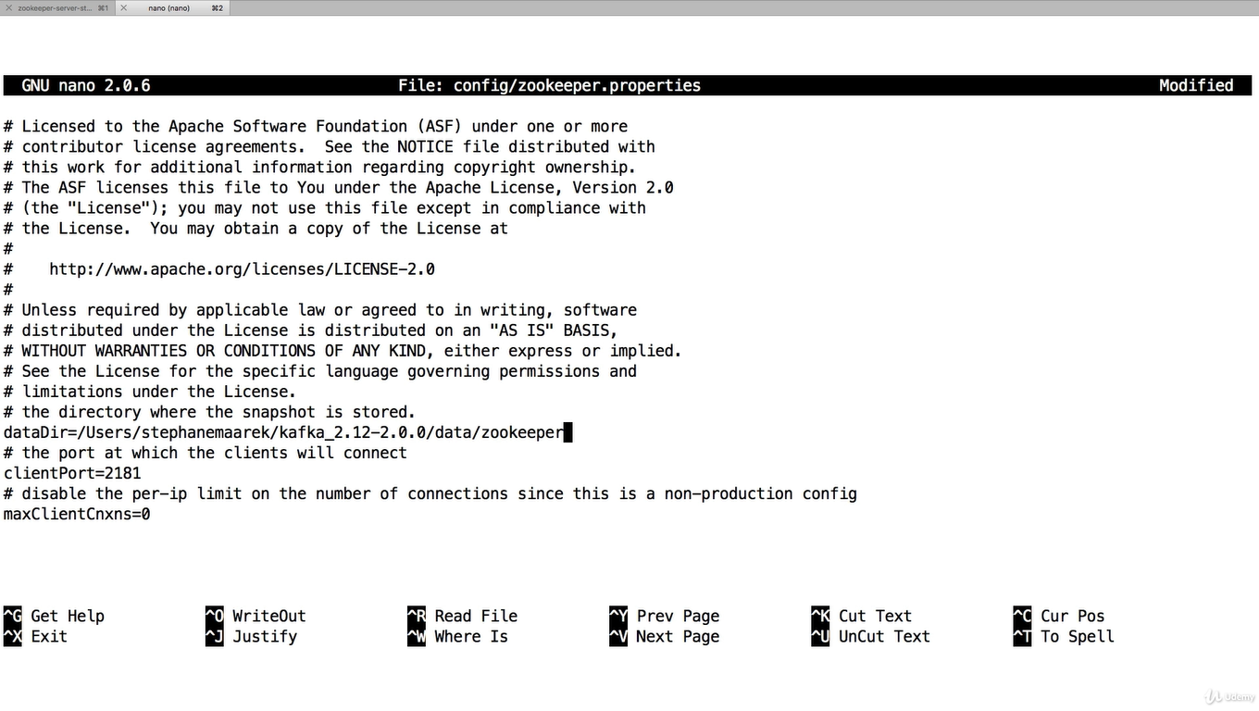

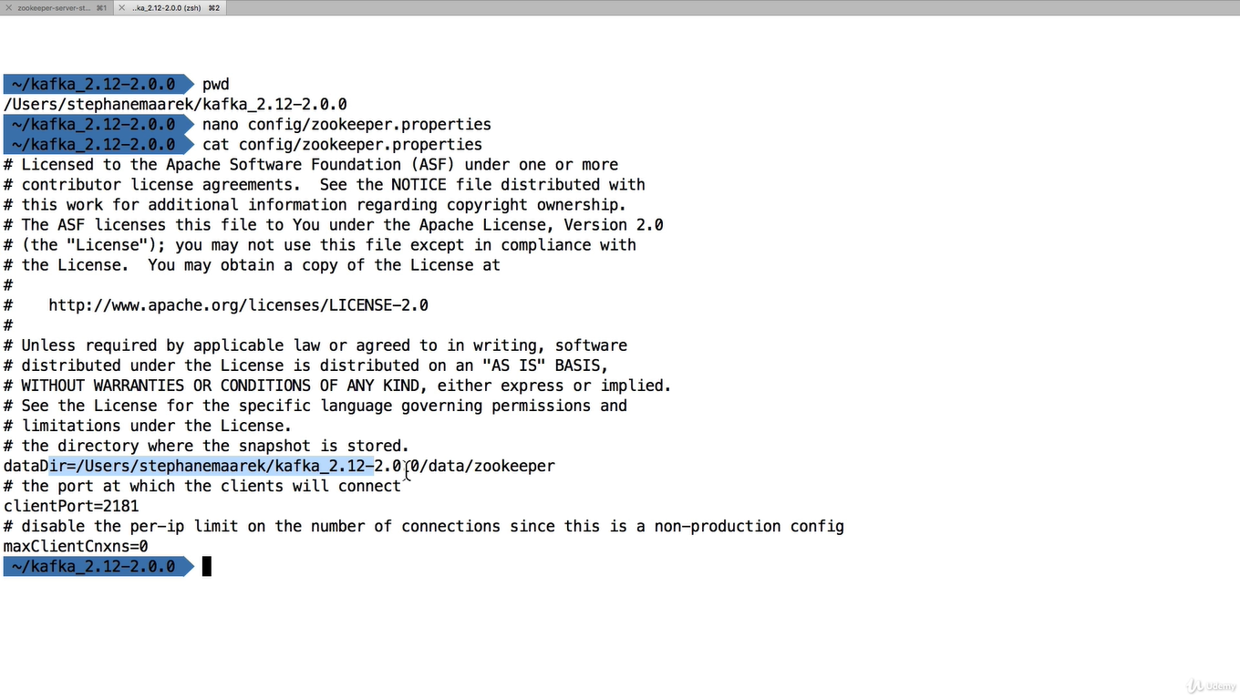

Now we are going to crate another folder for kafka

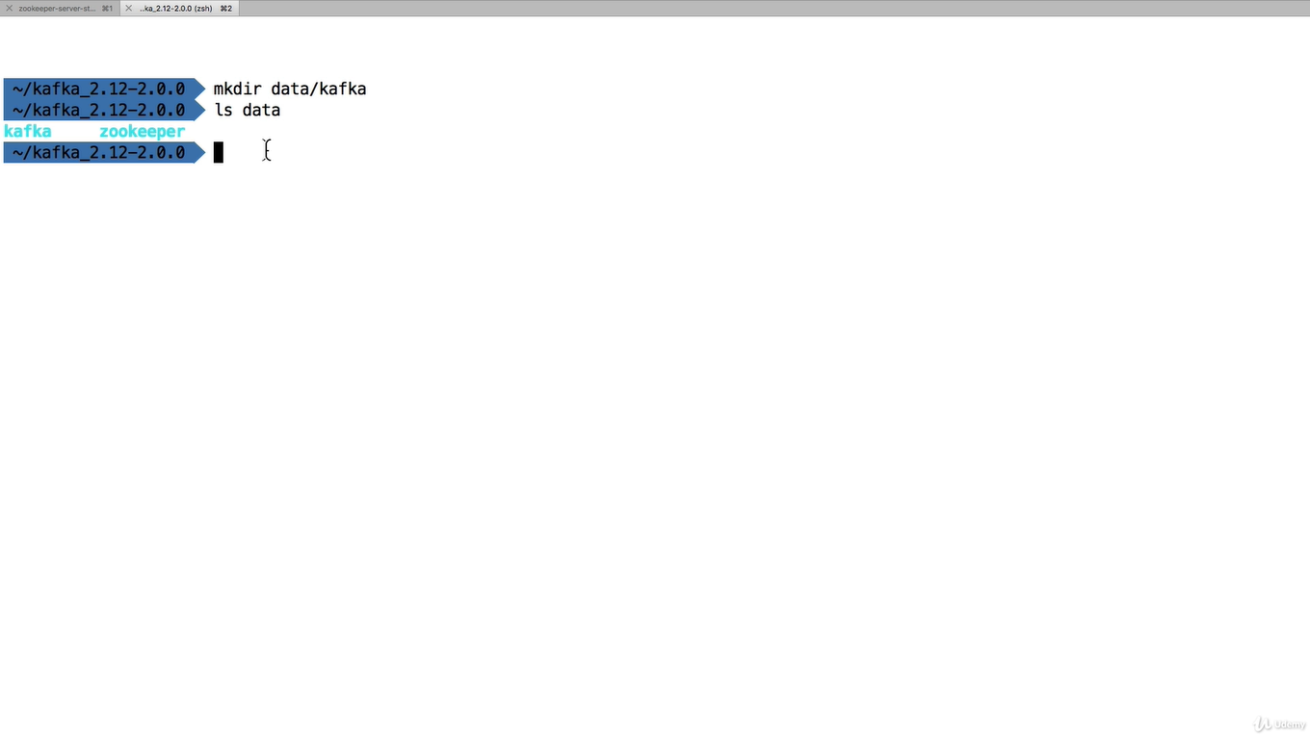

We are going update kafka properties with previously created dir

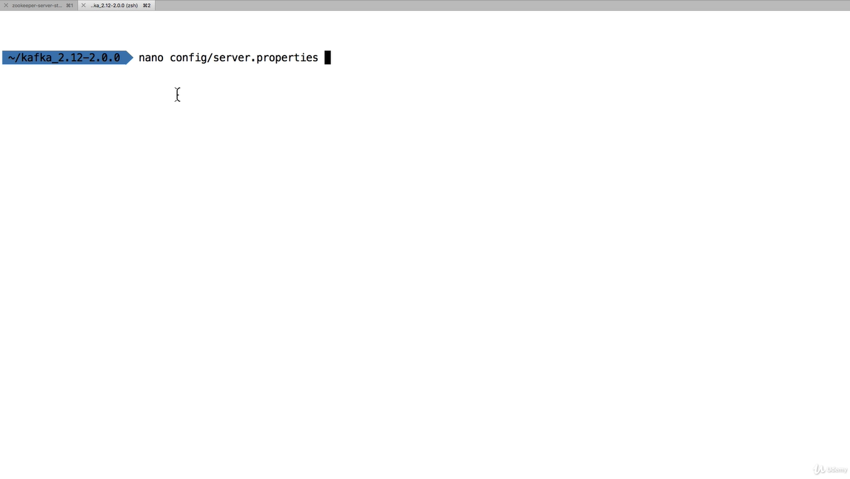

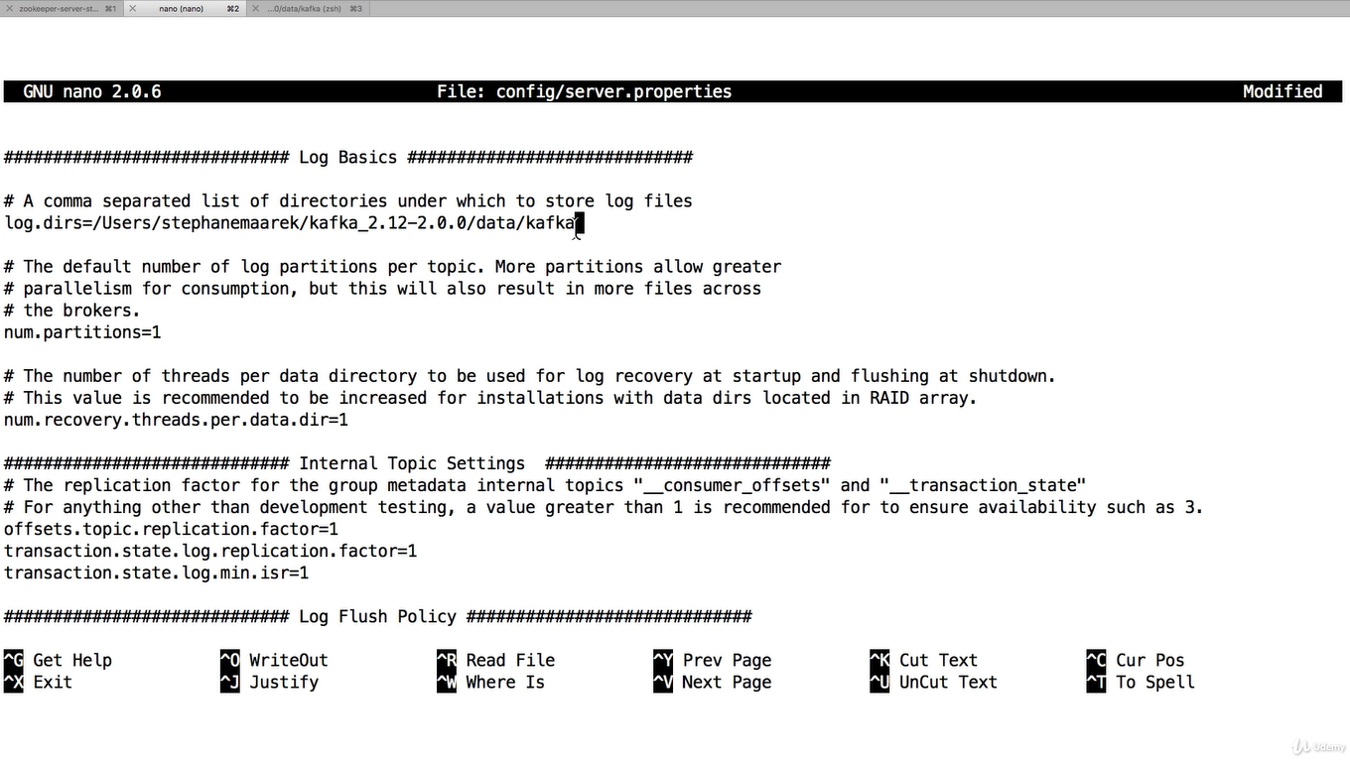now we are going to start kafka

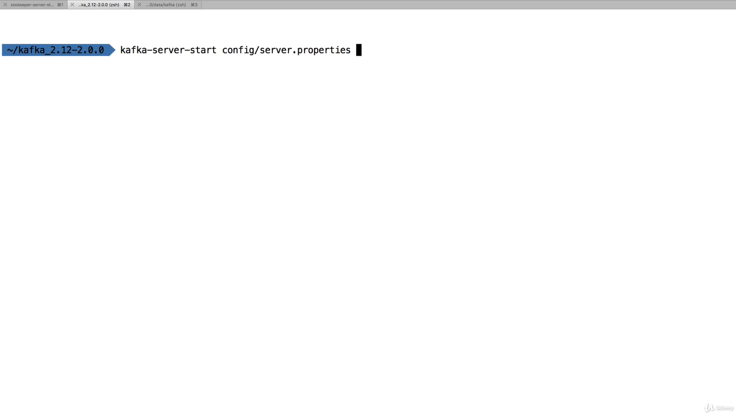

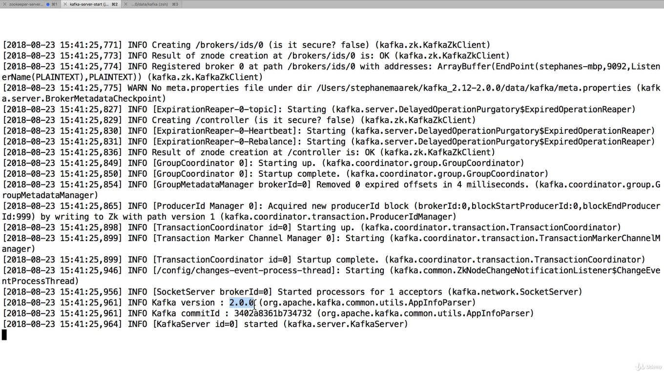

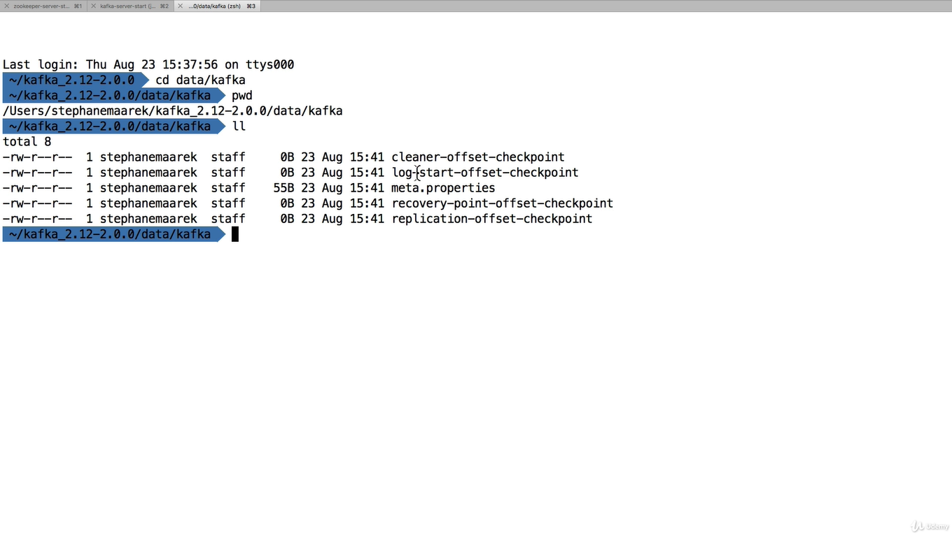

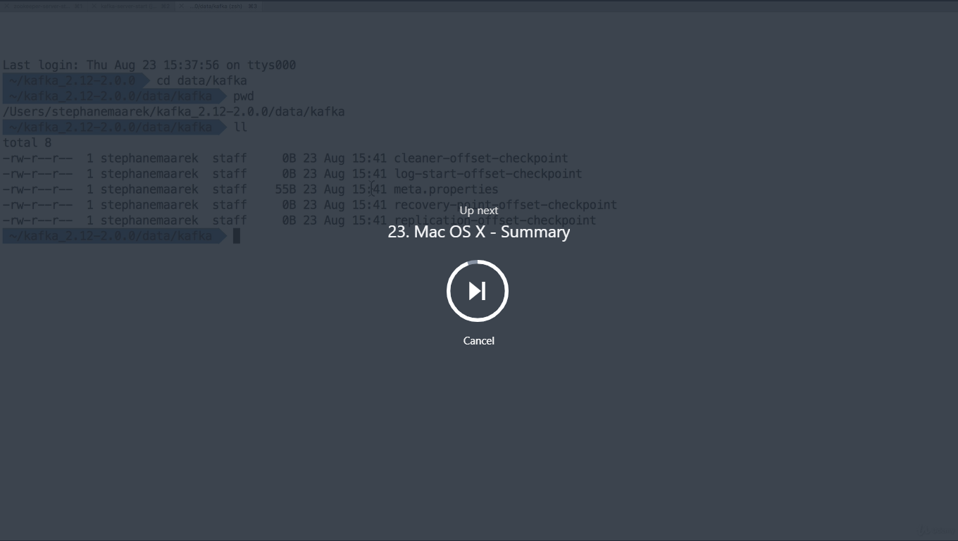

Mac OS X - Summary

**In summary, for Mac OS X**

1. Install brew if needed: /usr/bin/ruby -e "$(curl -fsSL https://raw.githubusercontent.com/Homebrew/install/master/install)"
2. Download and Setup **Java 8 JDK:**
   1. brew tap caskroom/versions
   2. brew cask install java8
3. Download & Extract the Kafka binaries from <https://kafka.apache.org/downloads>
4. Install Kafka commands using brew: brew install kafka
5. Try Kafka commands using kafka-topics (for example)
6. Edit Zookeeper & Kafka configs using a text editor
   1. zookeeper.properties: dataDir=/your/path/to/data/zookeeper
   2. server.properties: log.dirs=/your/path/to/data/kafka
7. Start Zookeeper in one terminal window: zookeeper-server-start config/zookeeper.properties
8. Start Kafka in **another** terminal window: kafka-server-start config/server.properties

Fullscreen

Go to

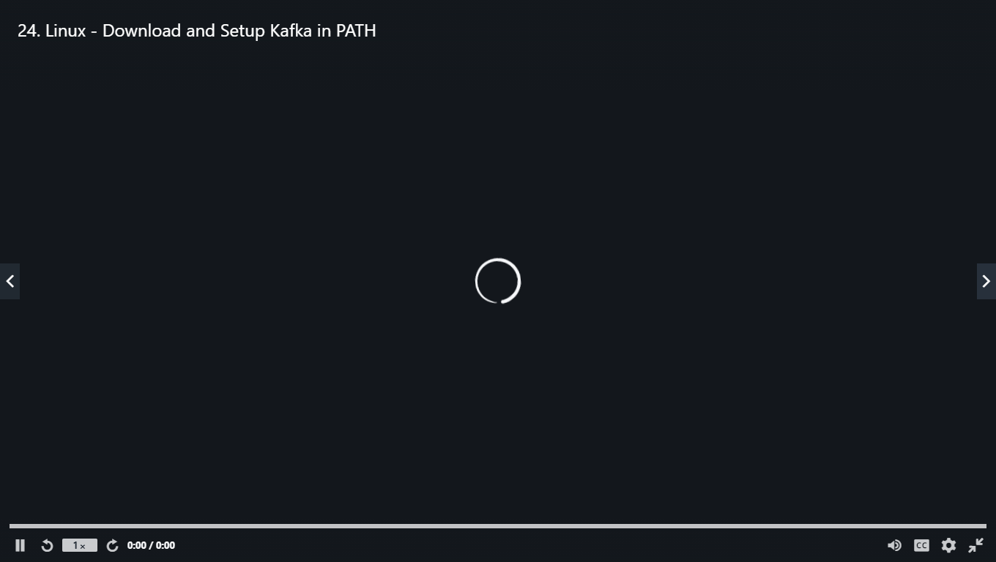

Check whether java 8 is installed by checking java -version

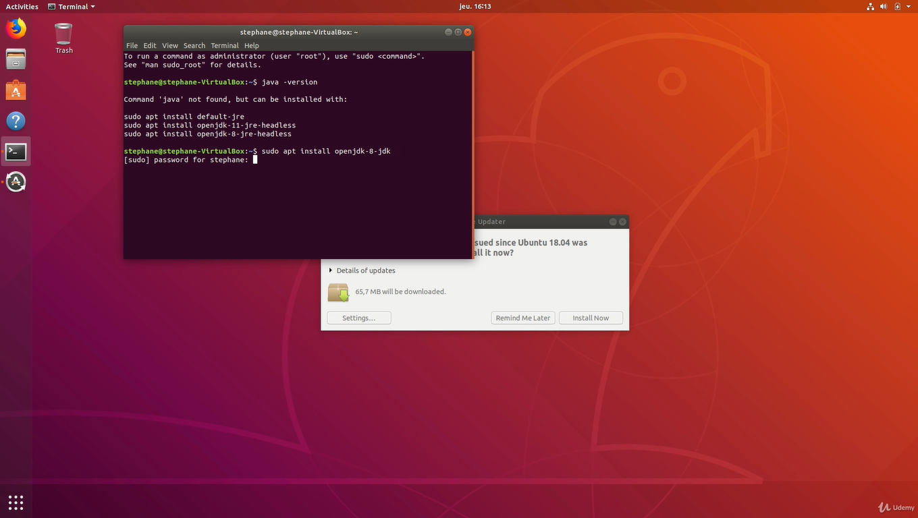

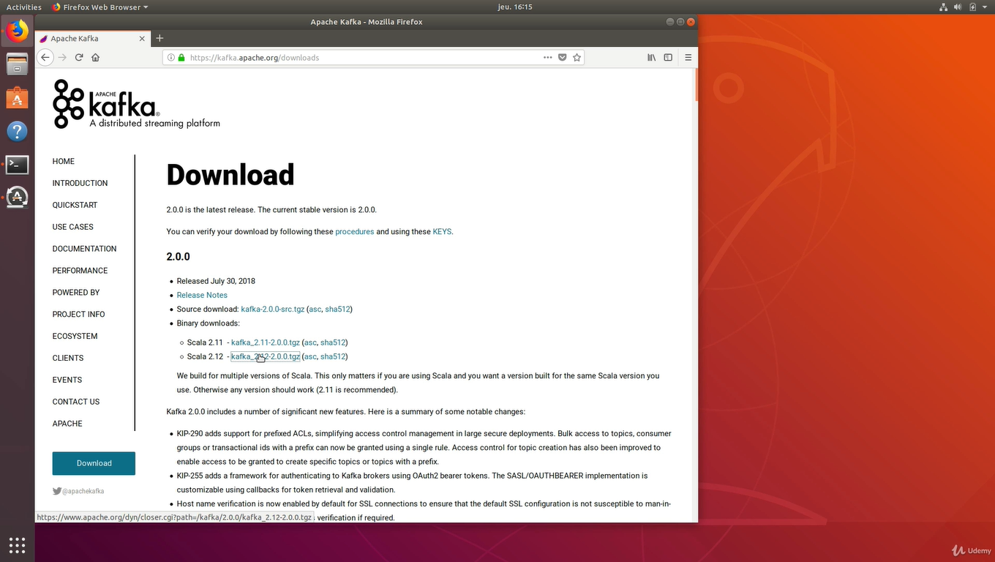\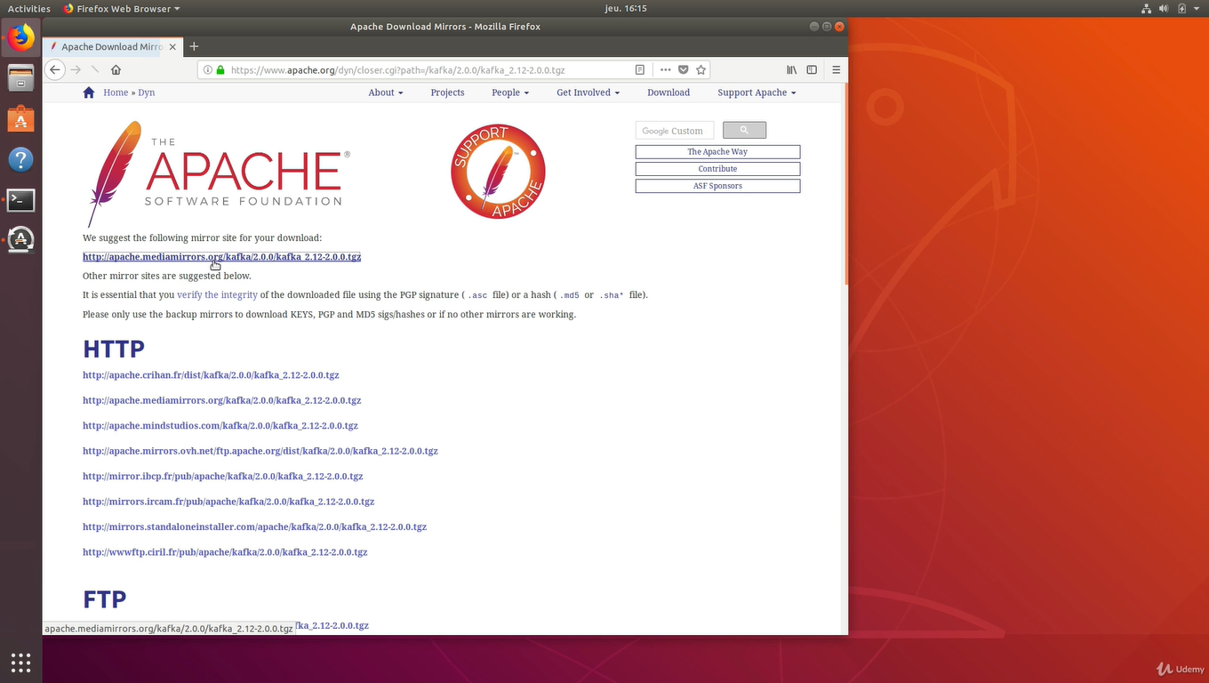

Extract it and go to kafka directory

Check kafka is installed

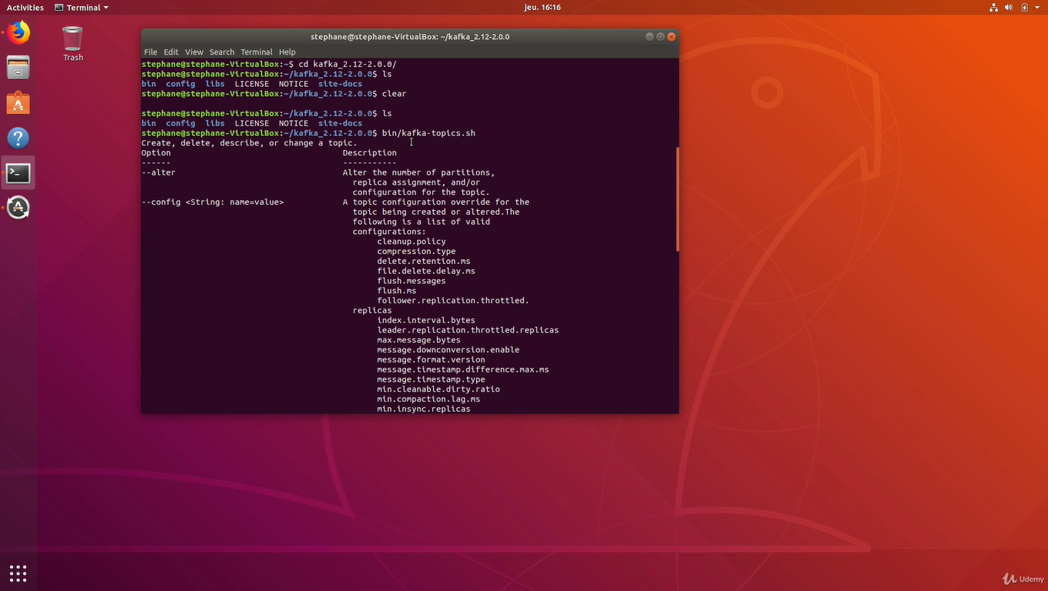

Check the path now

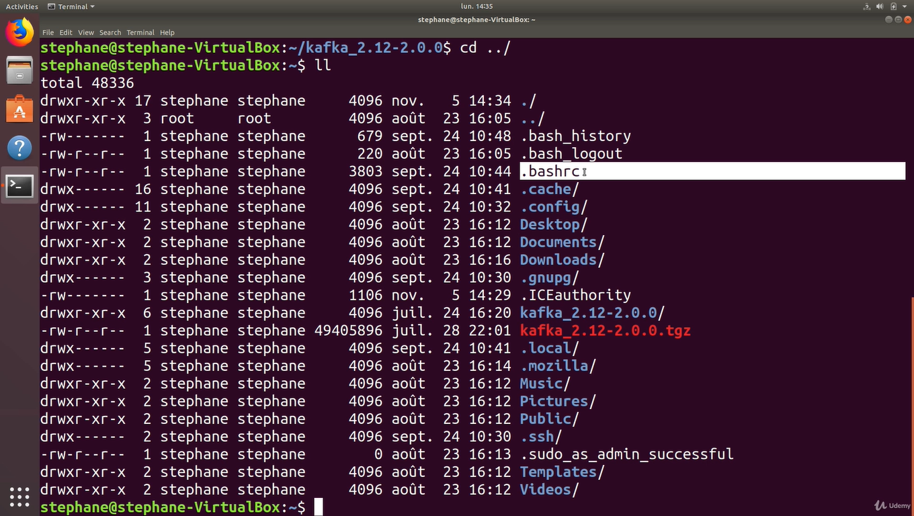

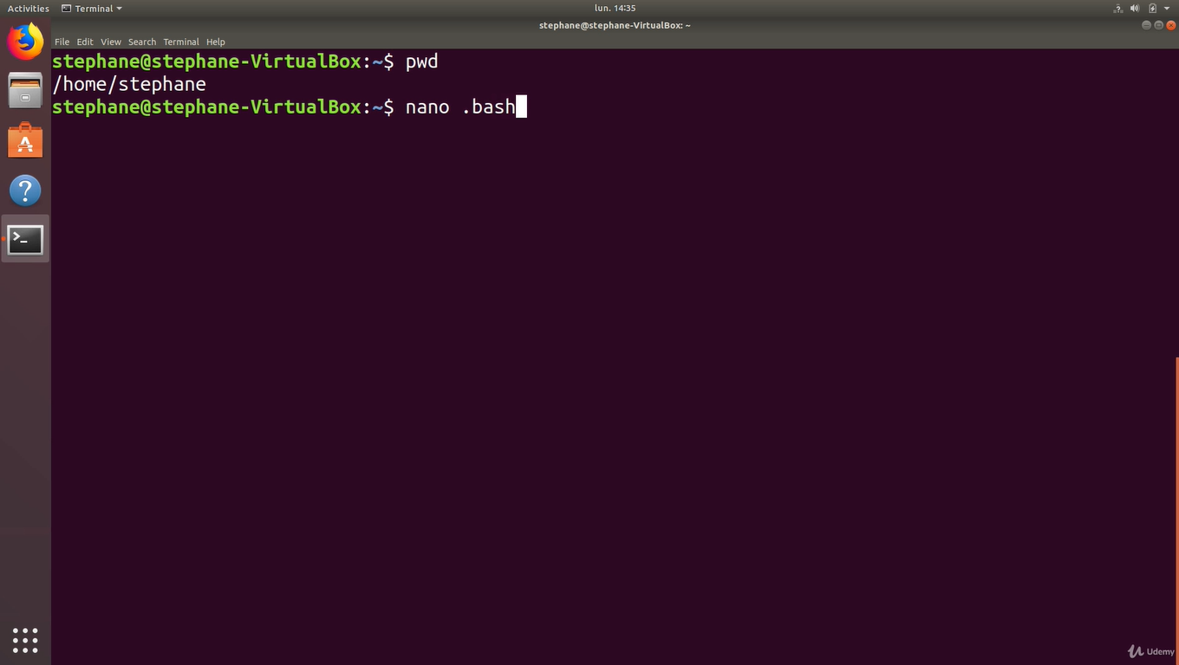

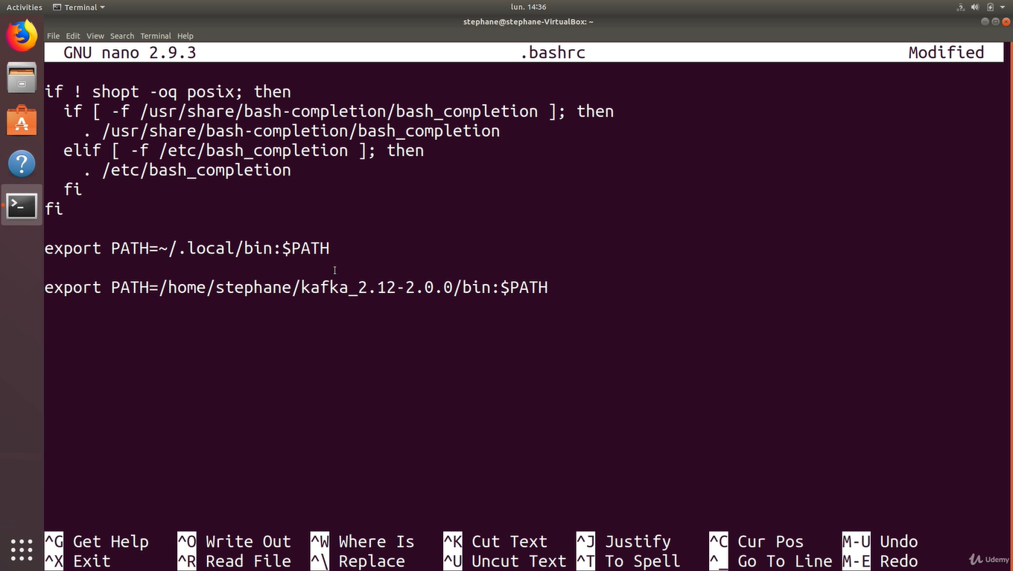

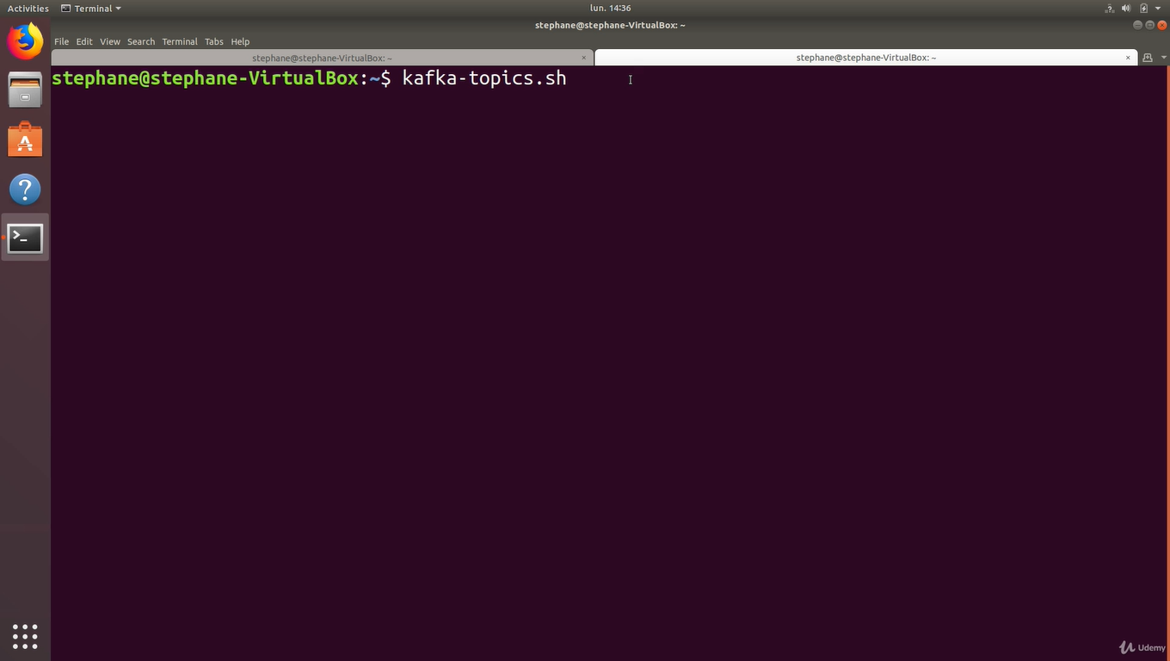

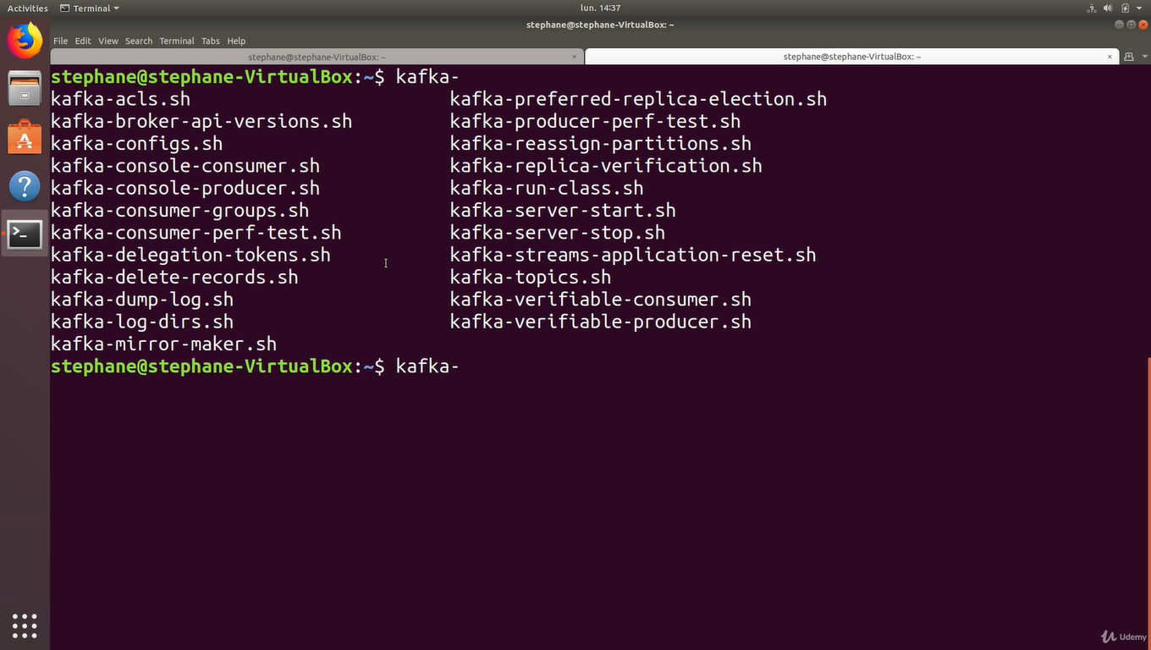

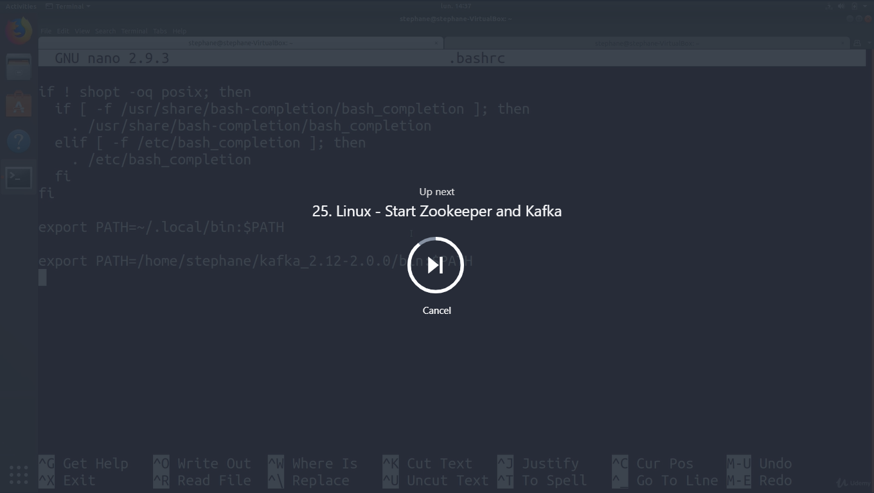

Create directories for zookeeper

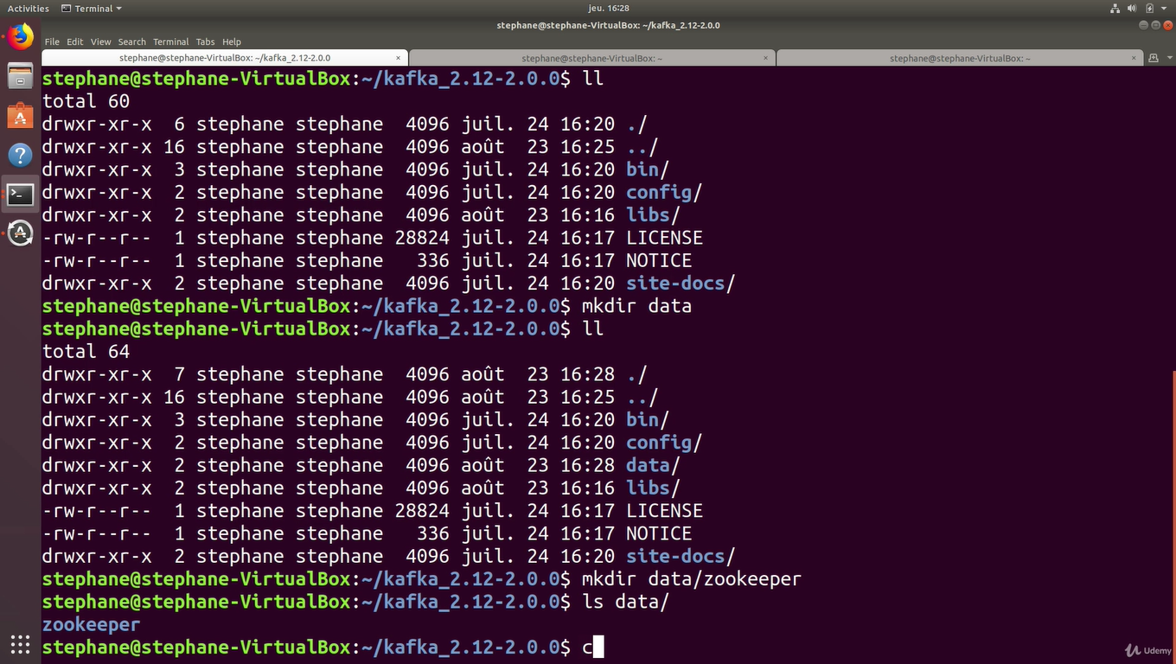

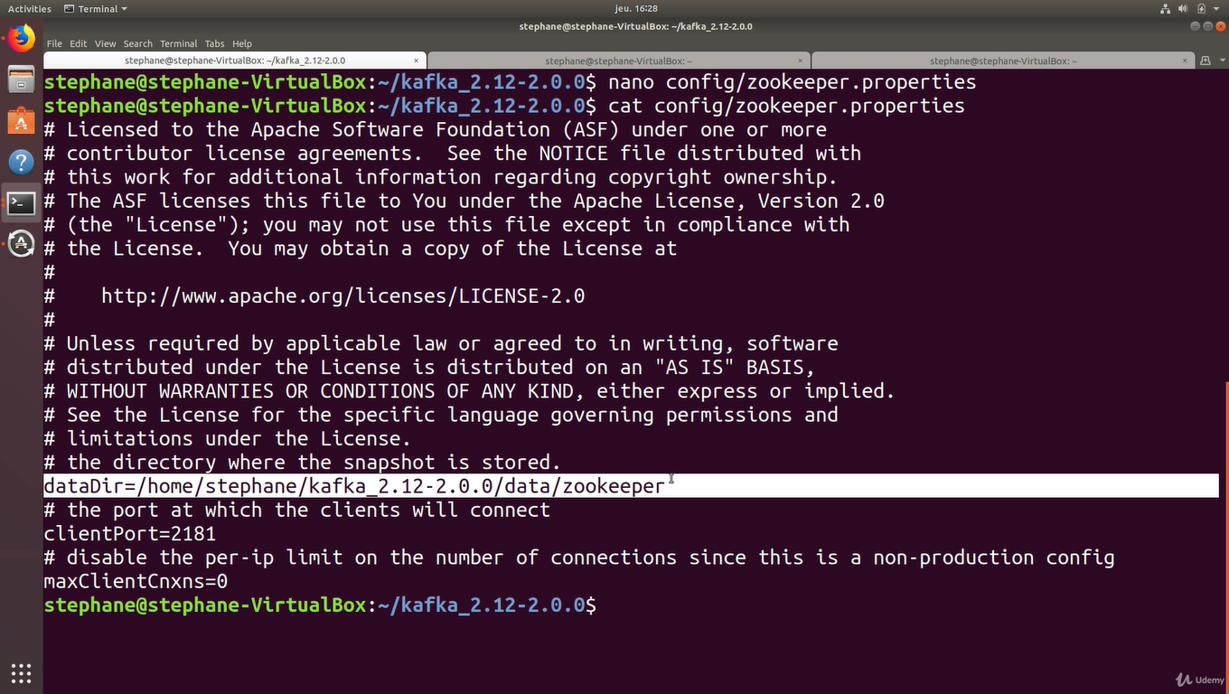

Not required to give bin/

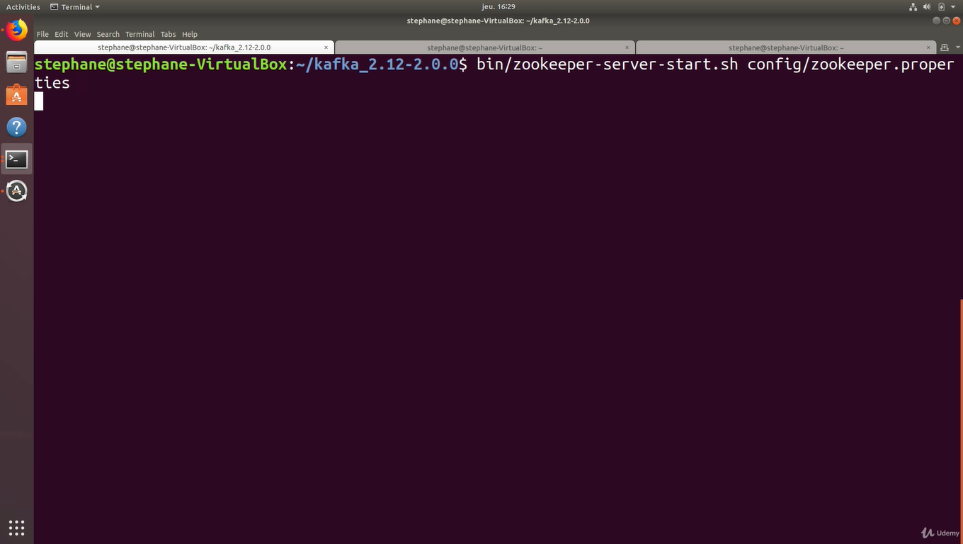

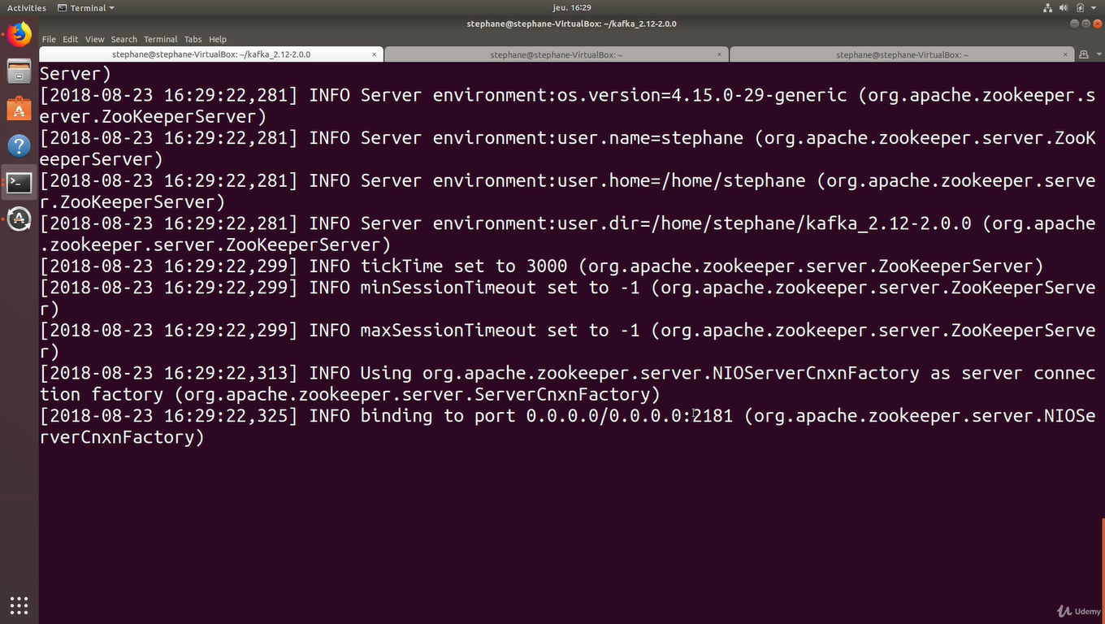

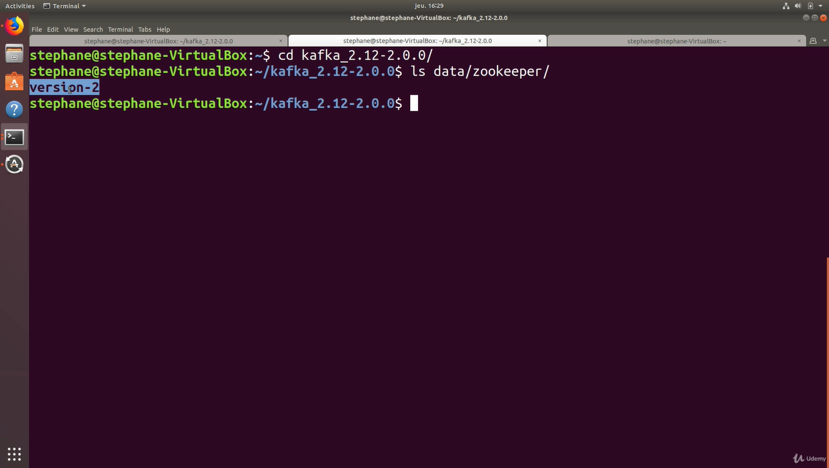

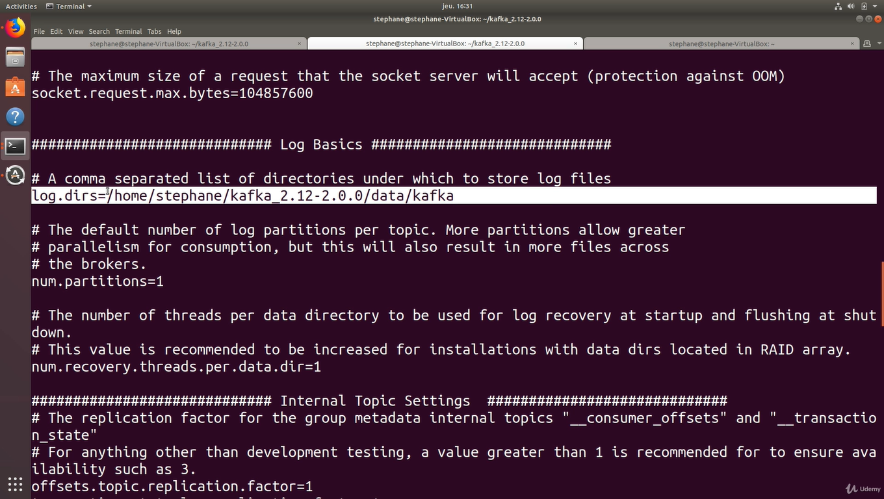

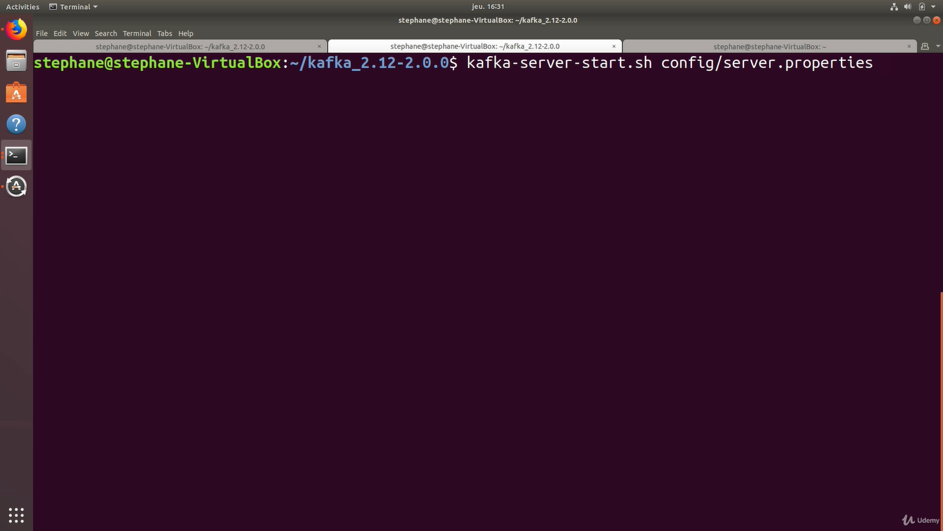

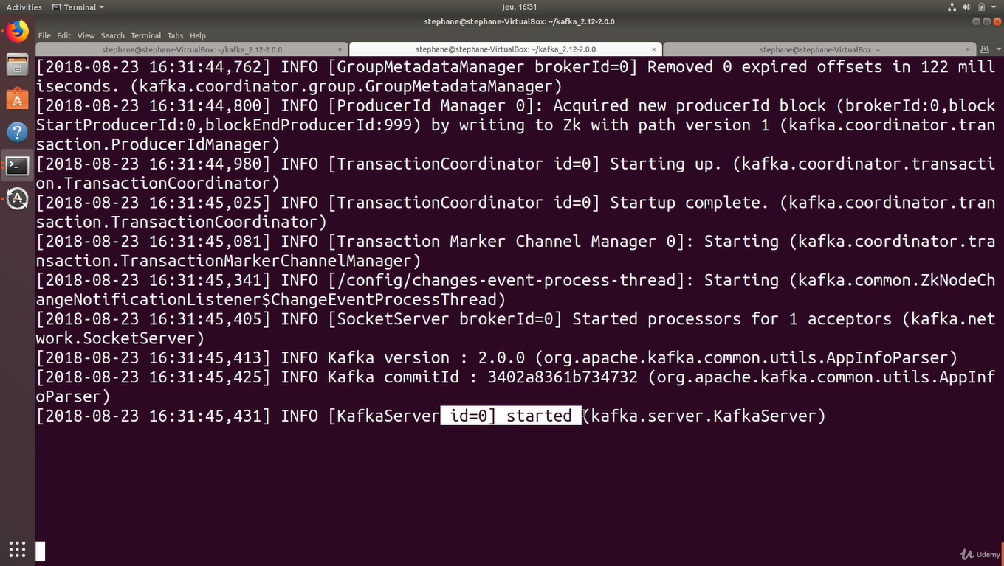

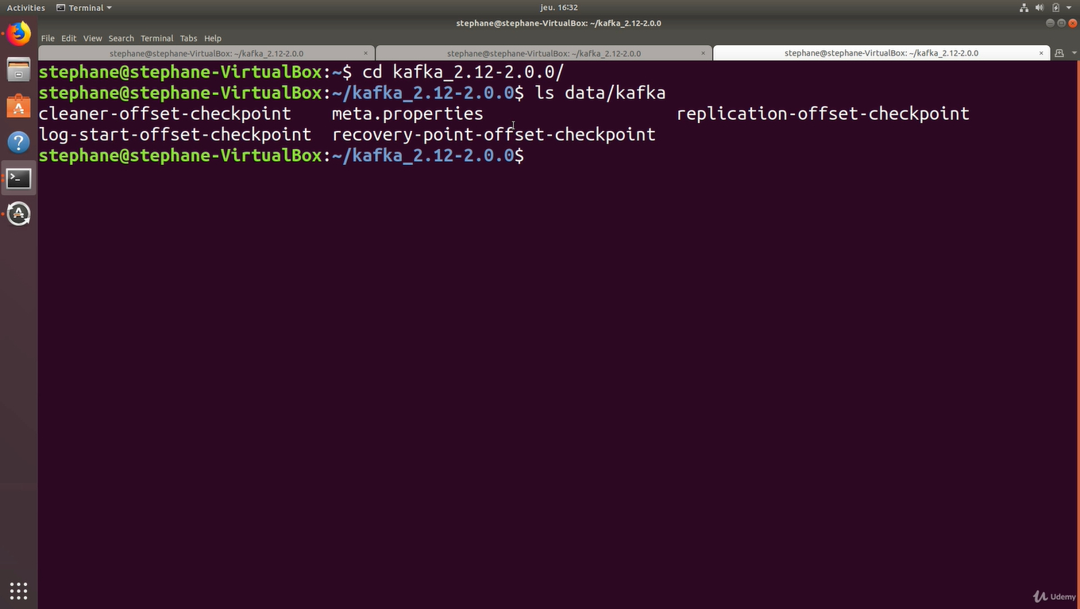

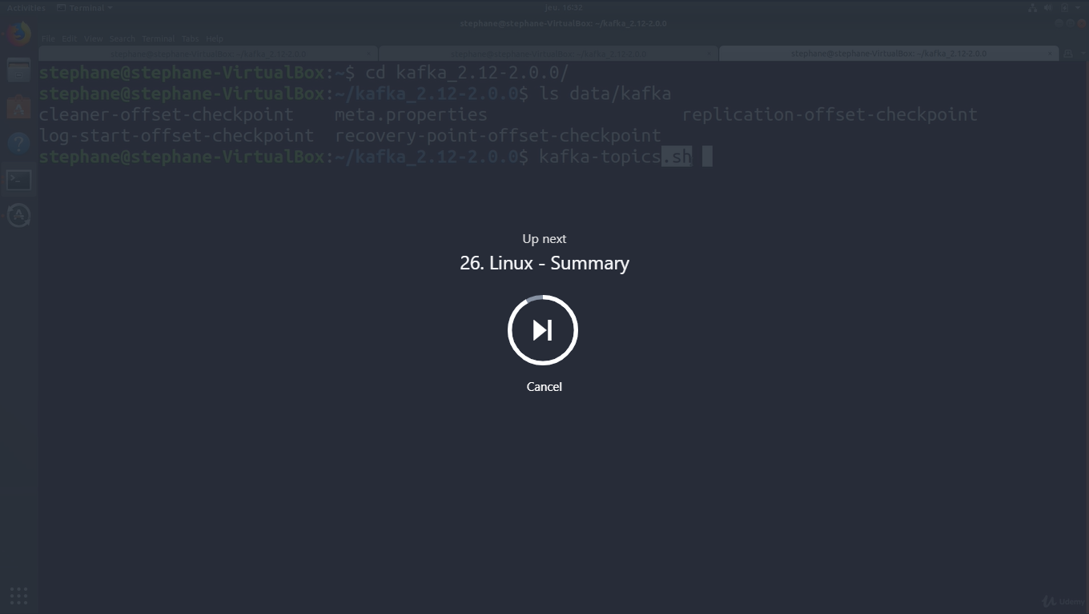

Linux - Summary

**In summary, for Linux (ex: Ubuntu)**

1. Download and Setup **Java 8 JDK:**
   1. sudo apt install openjdk-8-jdk
2. Download & Extract the Kafka binaries from <https://kafka.apache.org/downloads>
3. Try Kafka commands using bin/kafka-topics.sh (for example)
4. Edit PATH to include Kafka (in ~/.bashrc for example) PATH="$PATH:/your/path/to/your/kafka/bin"
5. Edit Zookeeper & Kafka configs using a text editor
   1. zookeeper.properties: dataDir=/your/path/to/data/zookeeper
   2. server.properties: log.dirs=/your/path/to/data/kafka
6. Start Zookeeper in one terminal window: zookeeper-server-start.sh config/zookeeper.properties
7. Start Kafka in **another** terminal window: kafka-server-start.sh config/server.properties

**Important: For the rest of the course, don't forget to add the extension .sh to commands being run**

Fullscreen

Go to Previous lecture

25. Linux - Start Zookeeper and Kafka

Go to Next lecture

27. Windows - Download Kafka and PATH Setup

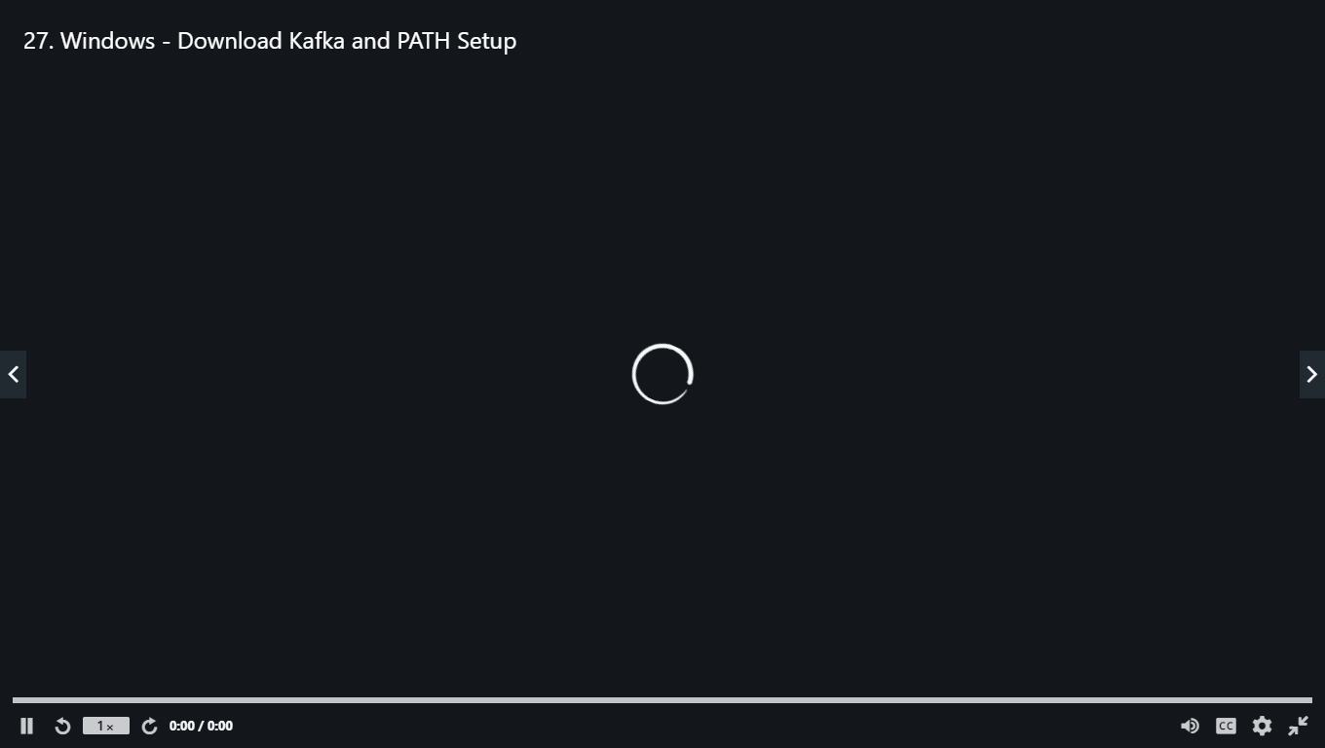

Install JDK 8

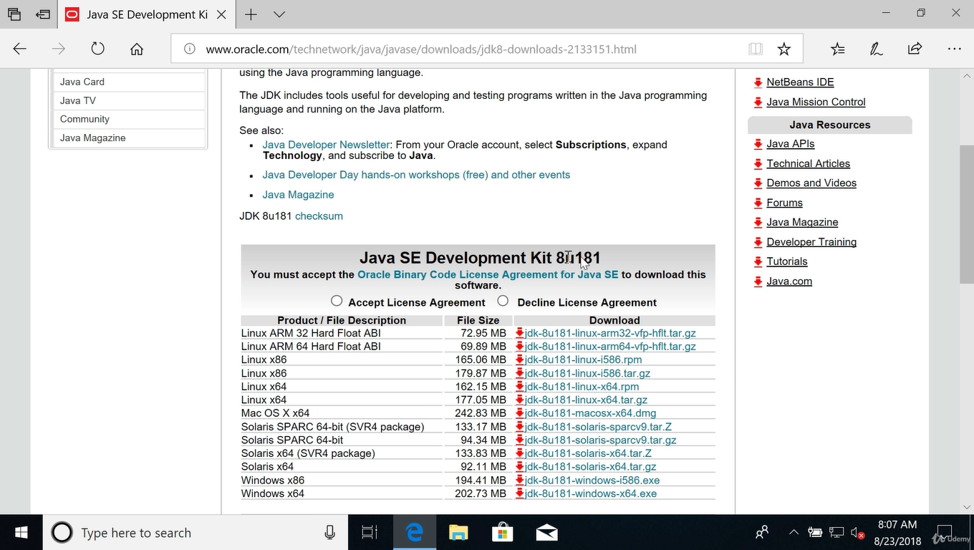

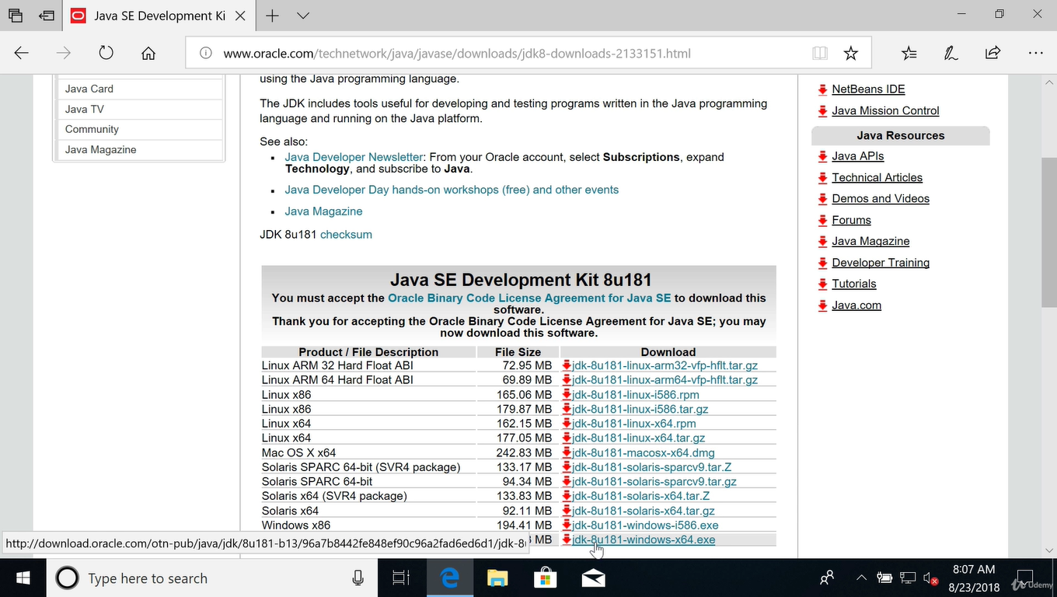\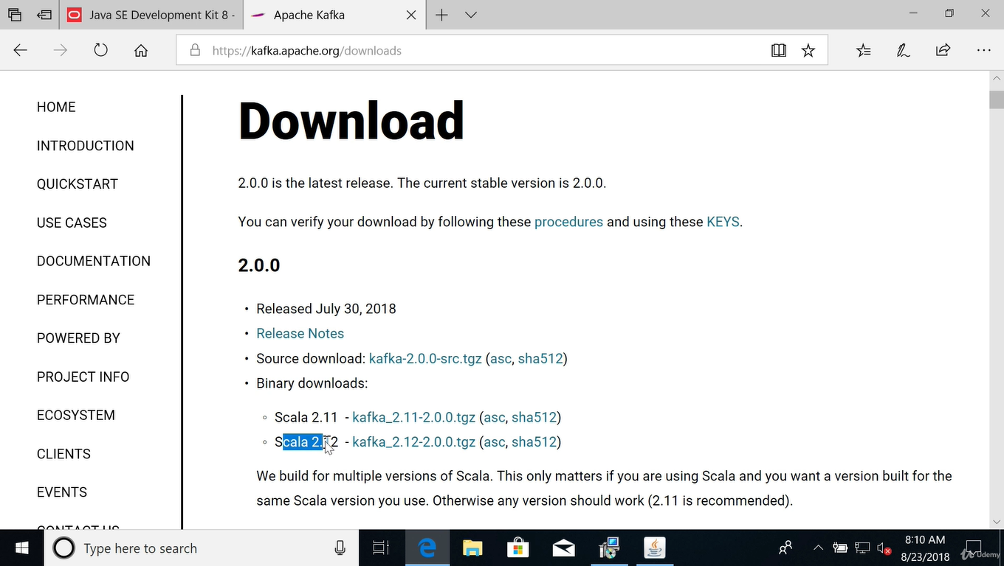

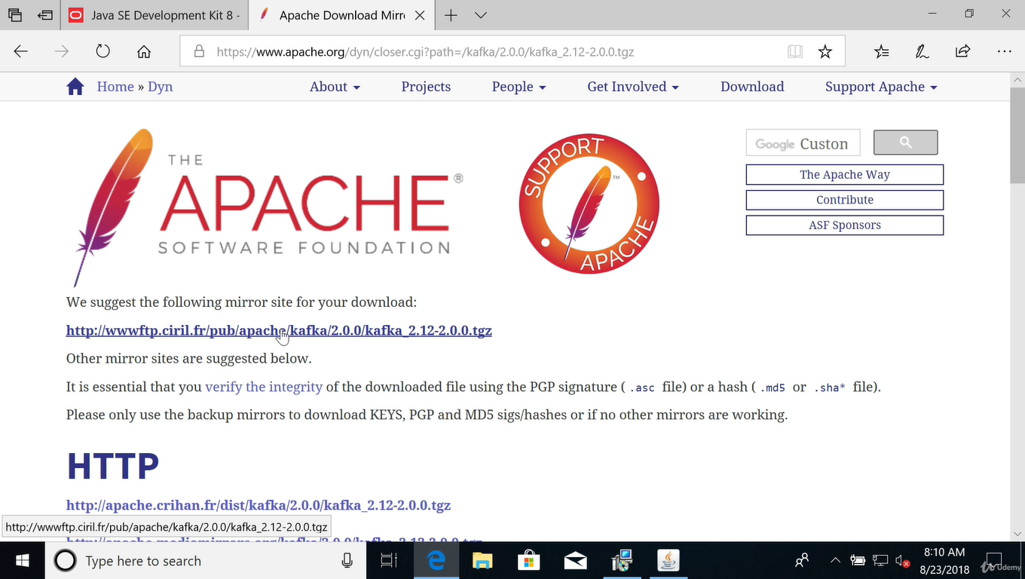

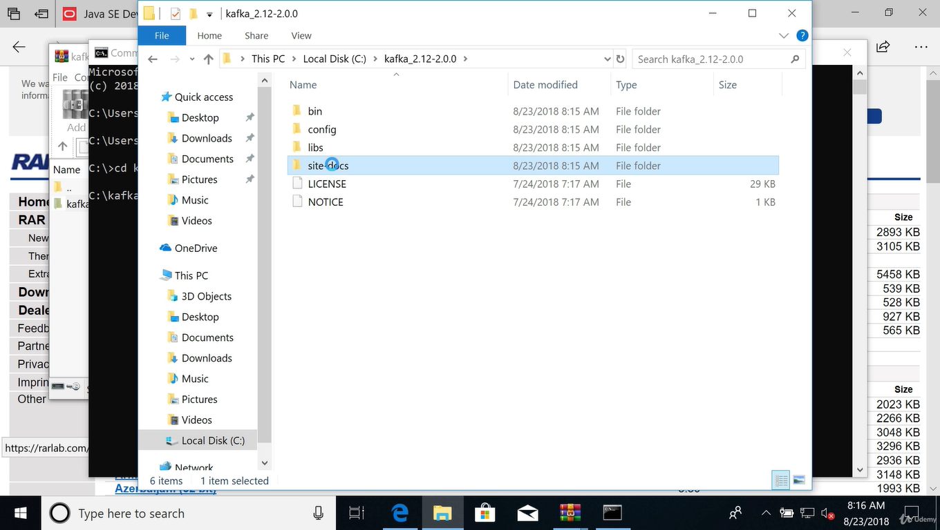

Check whether all install correctly

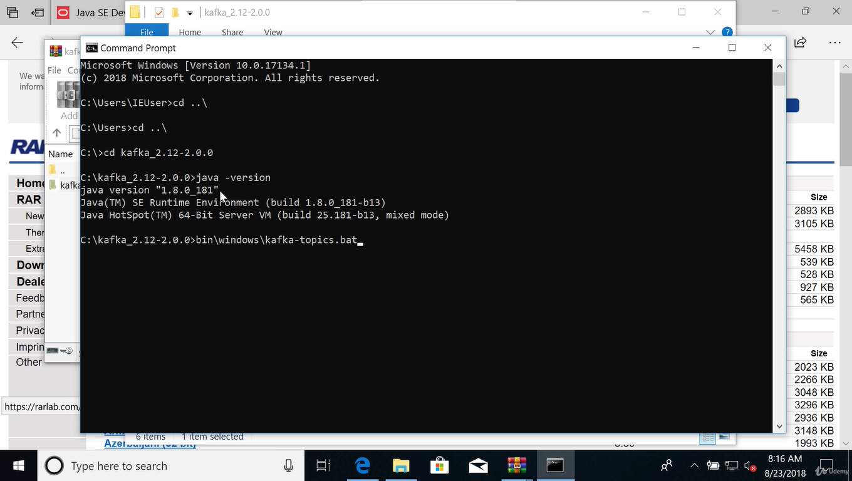

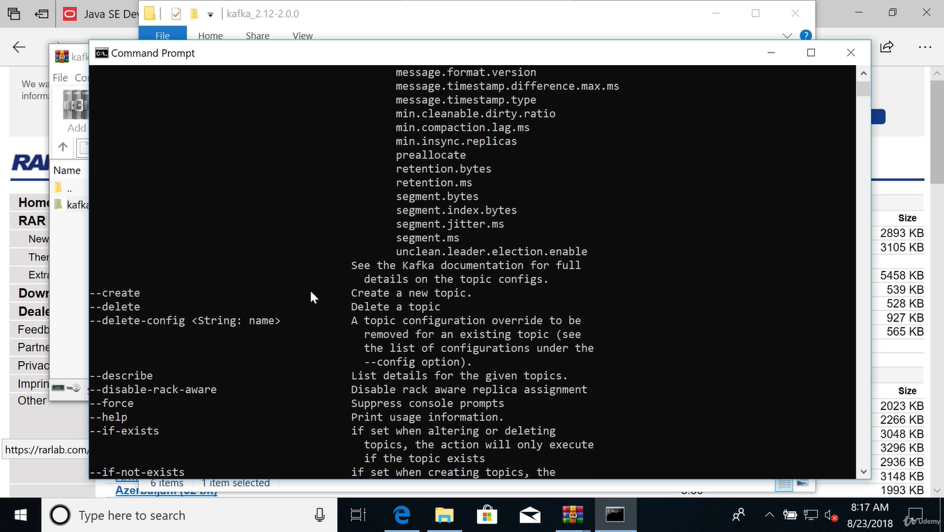

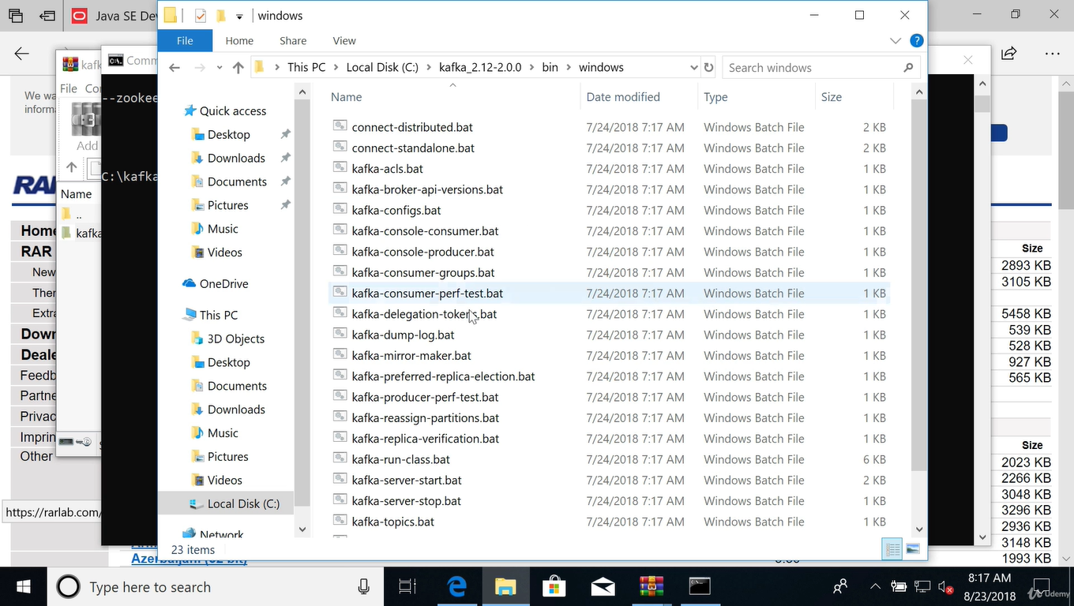

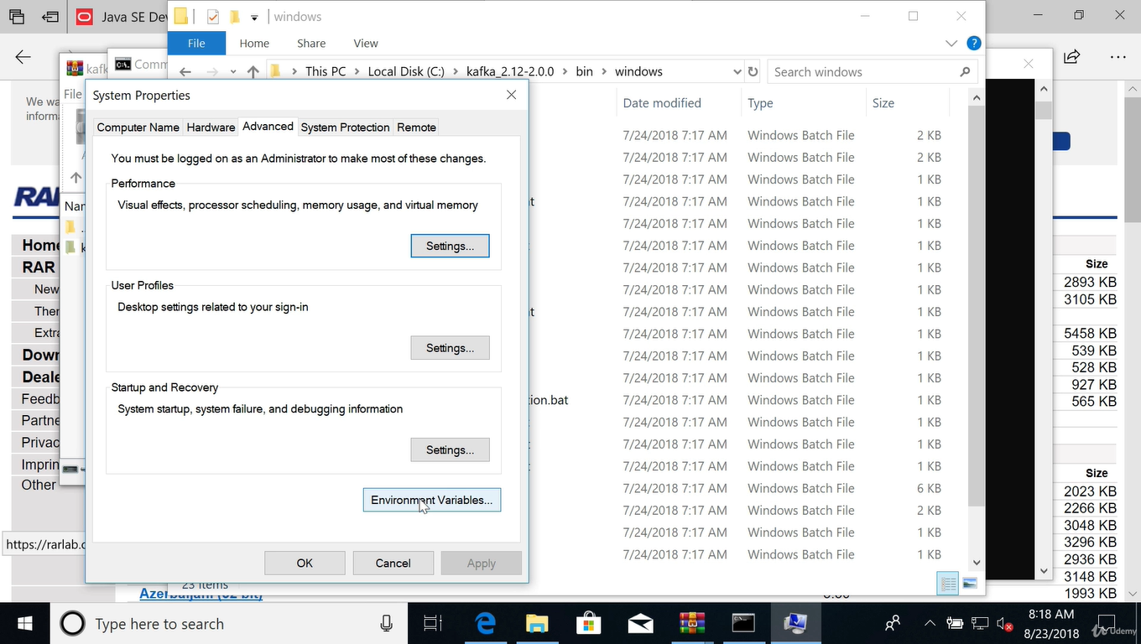

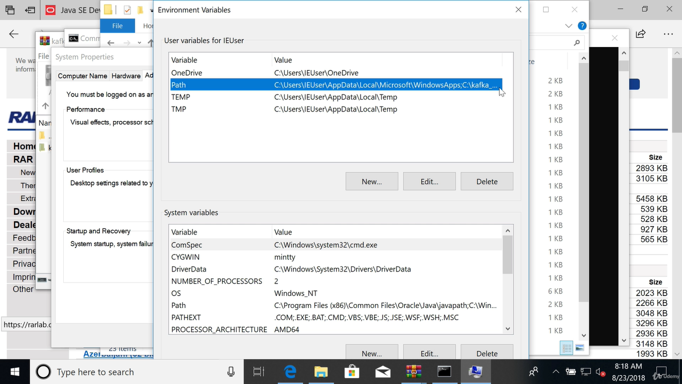

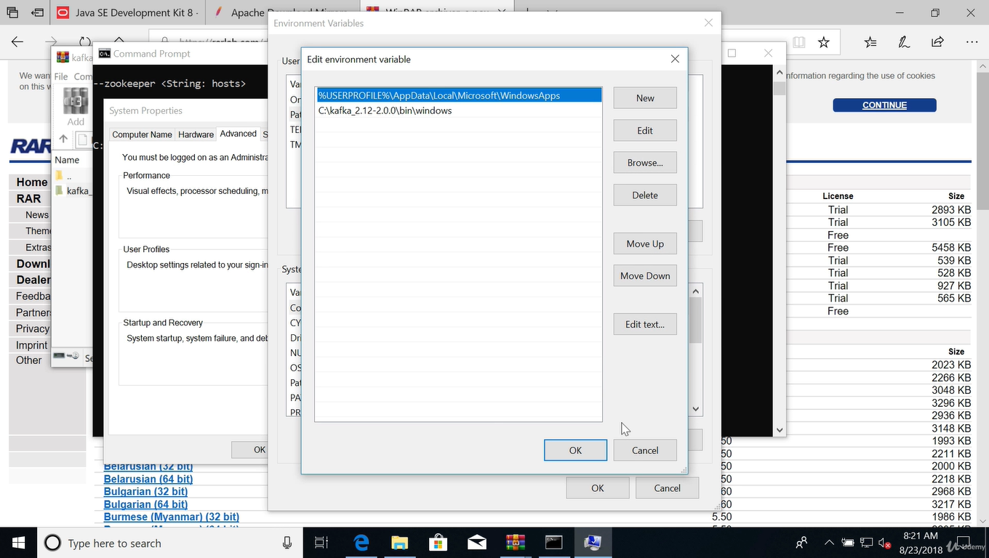

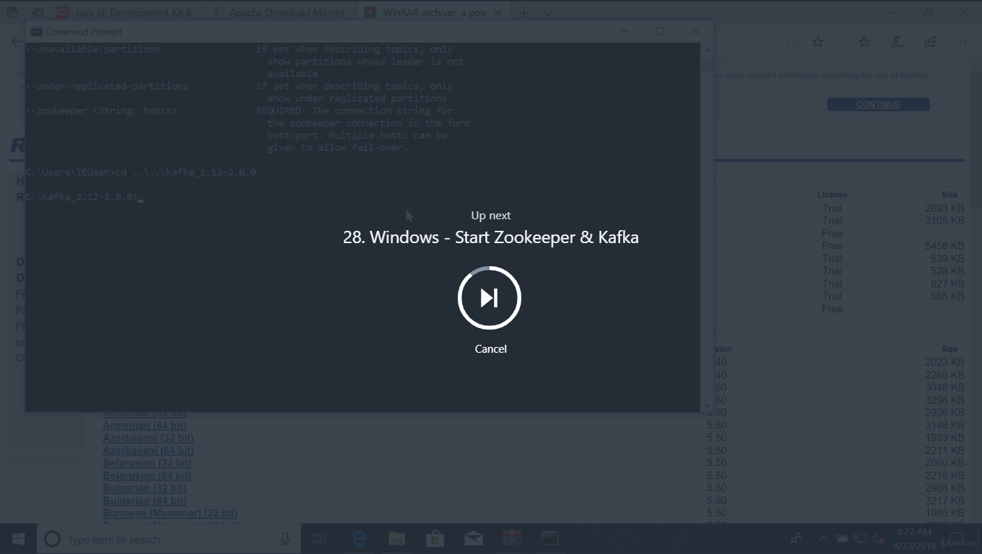

Create new folders for zooker & kafka

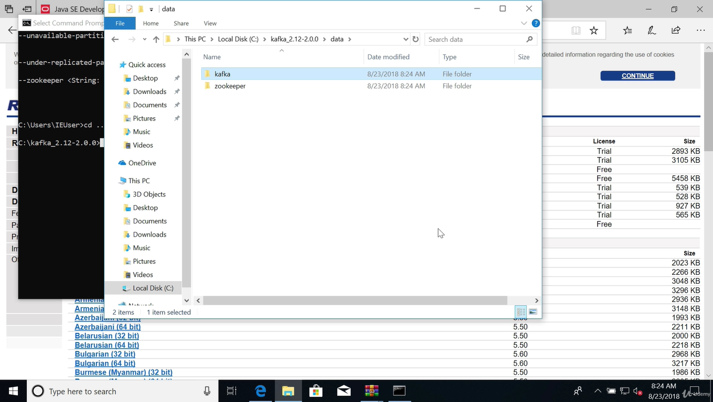

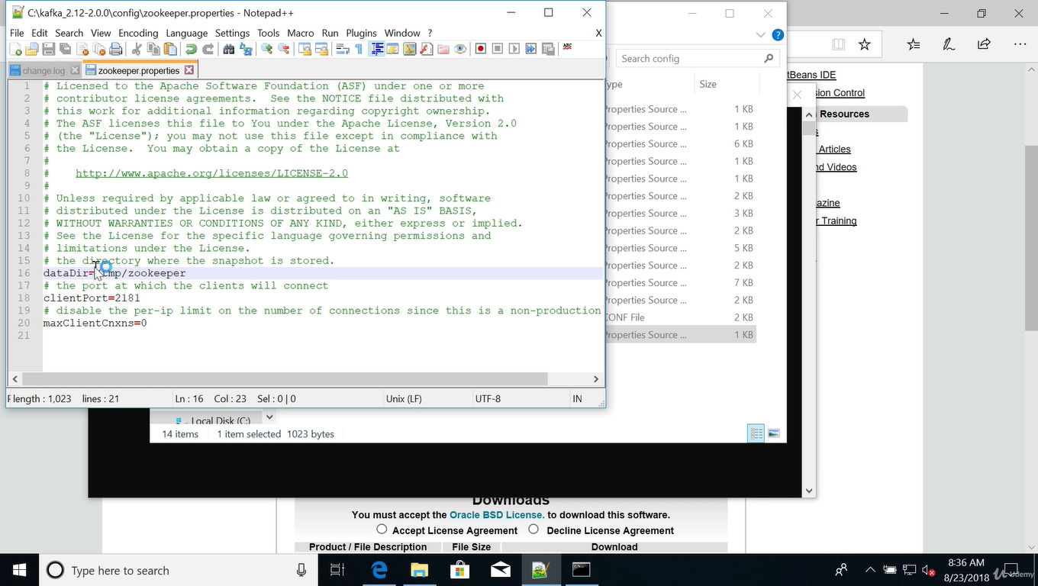

Start the zooker

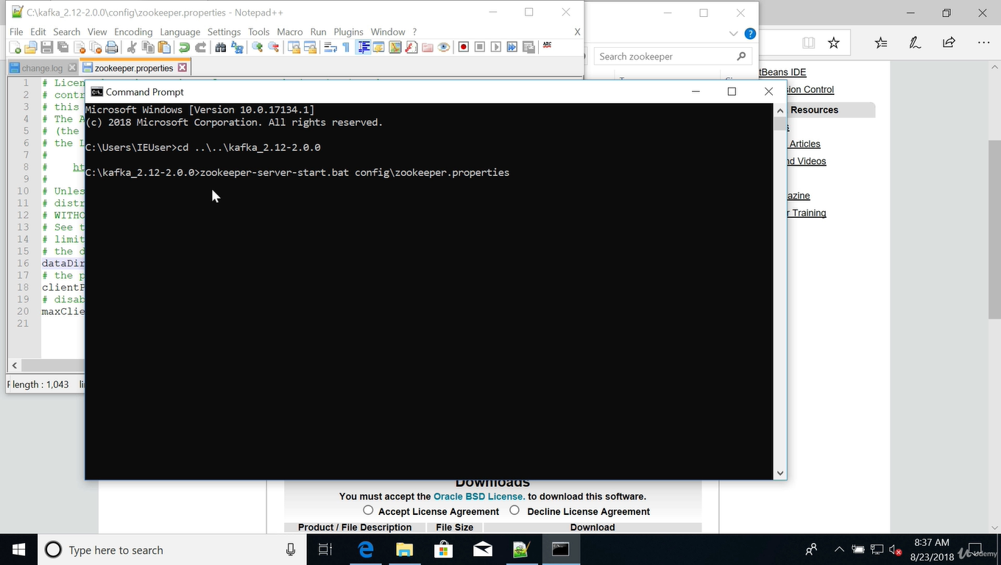

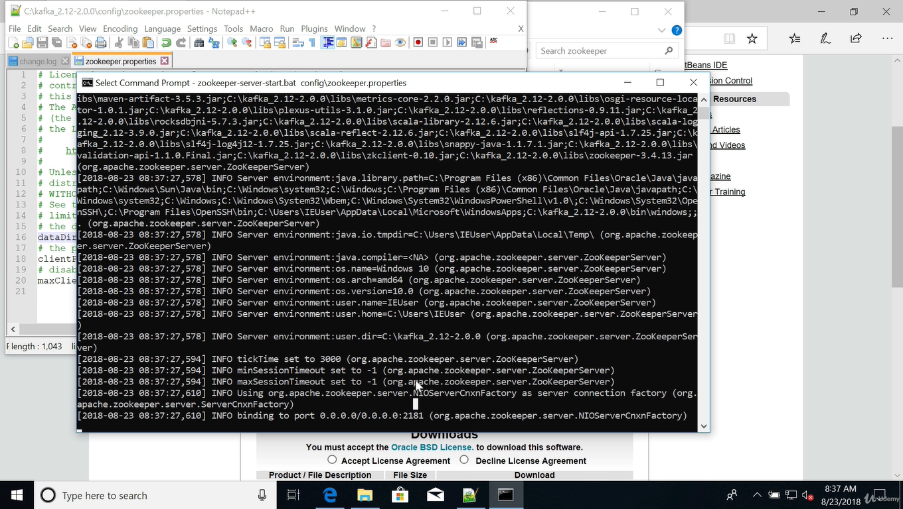

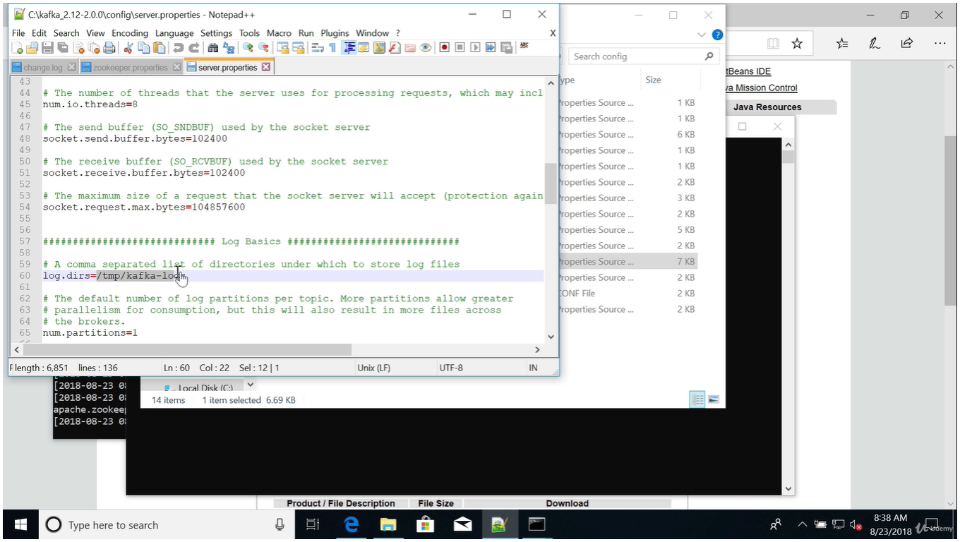

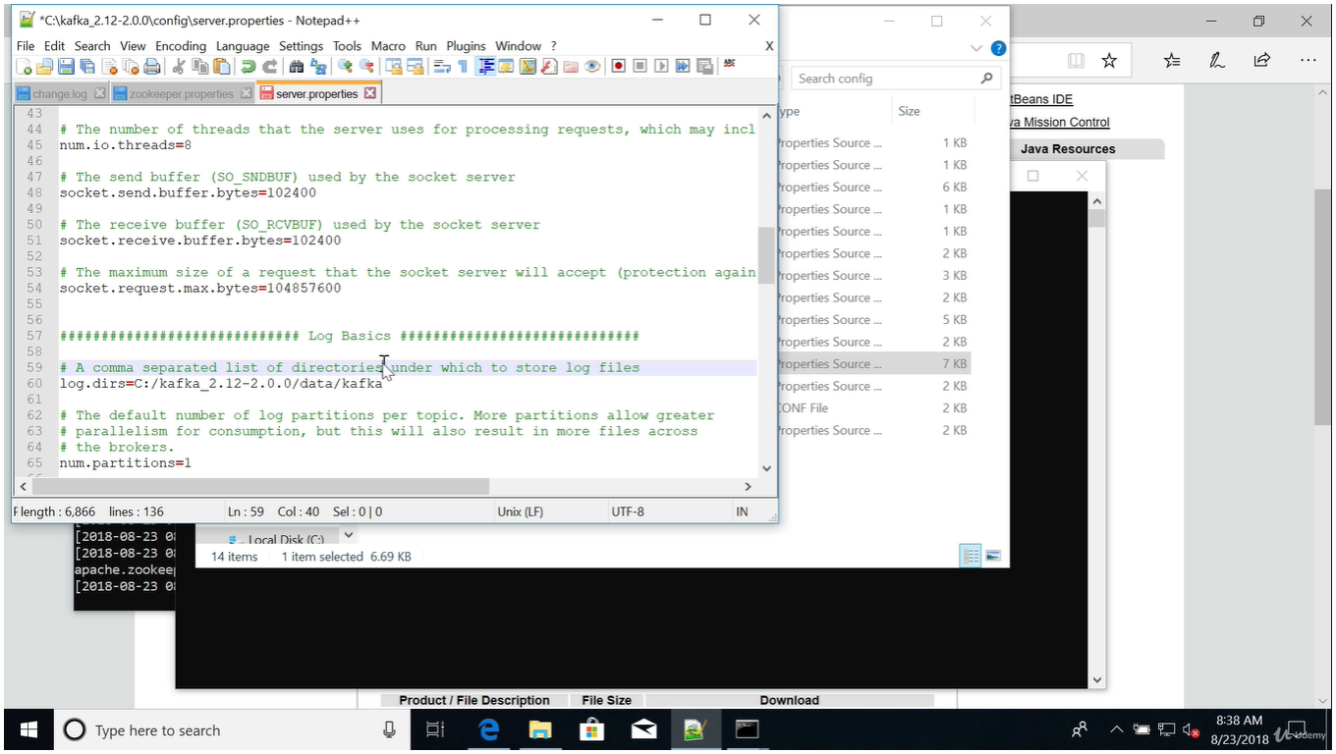

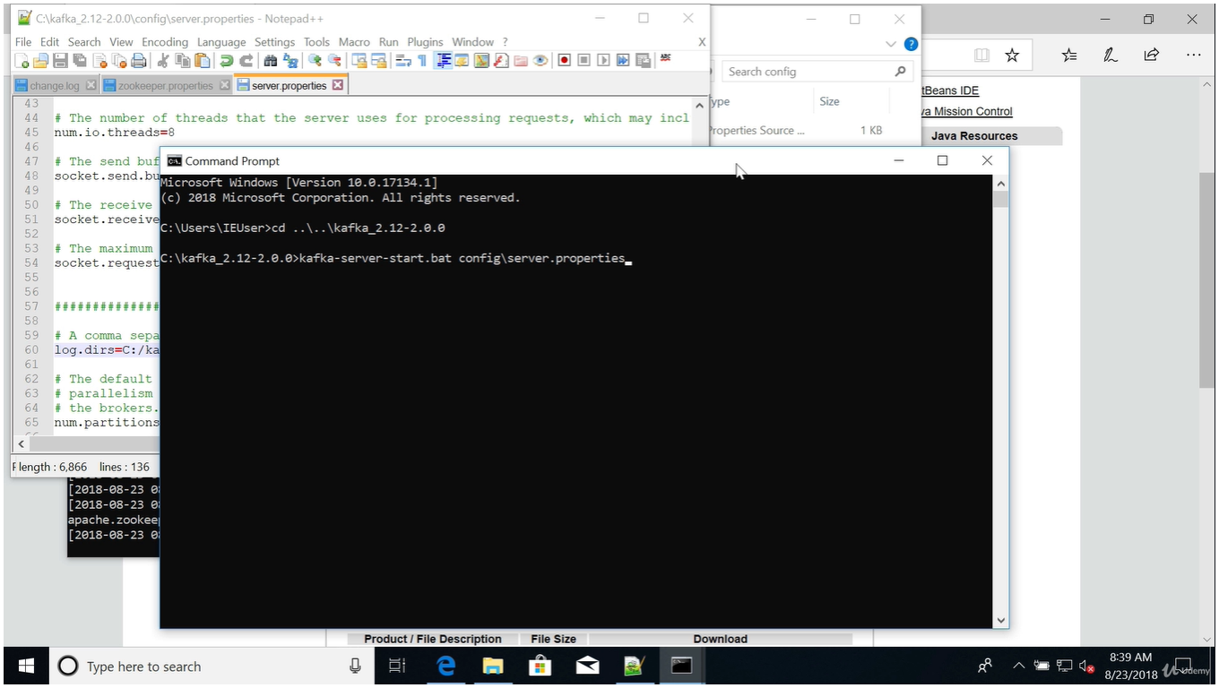

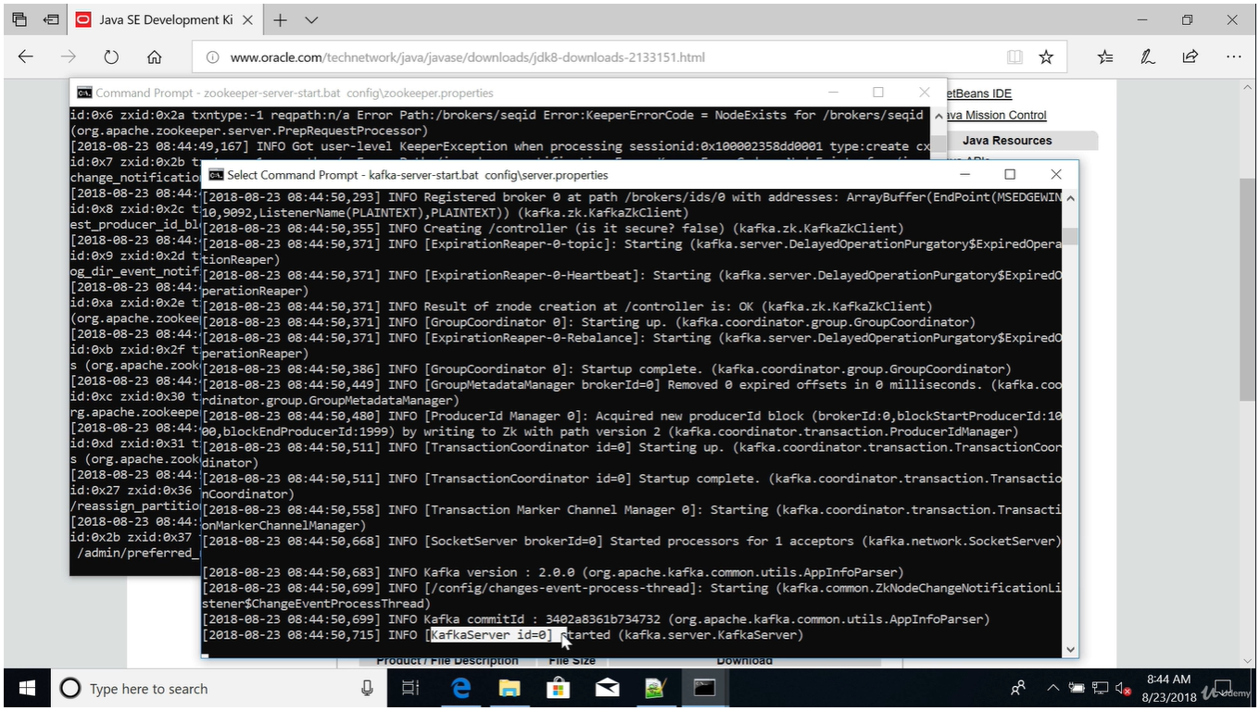

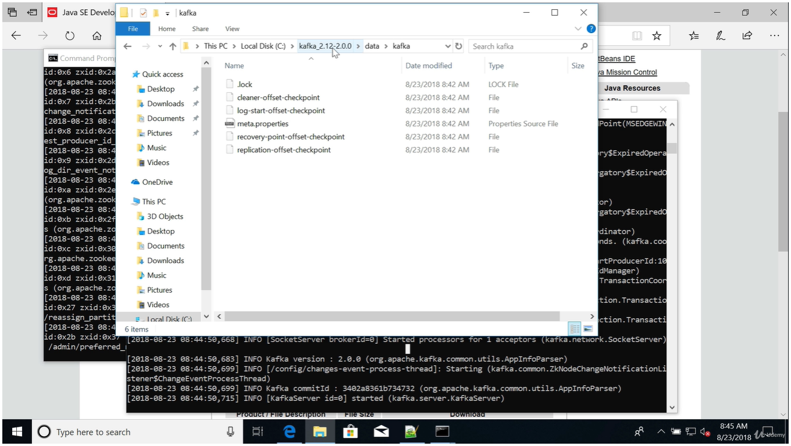

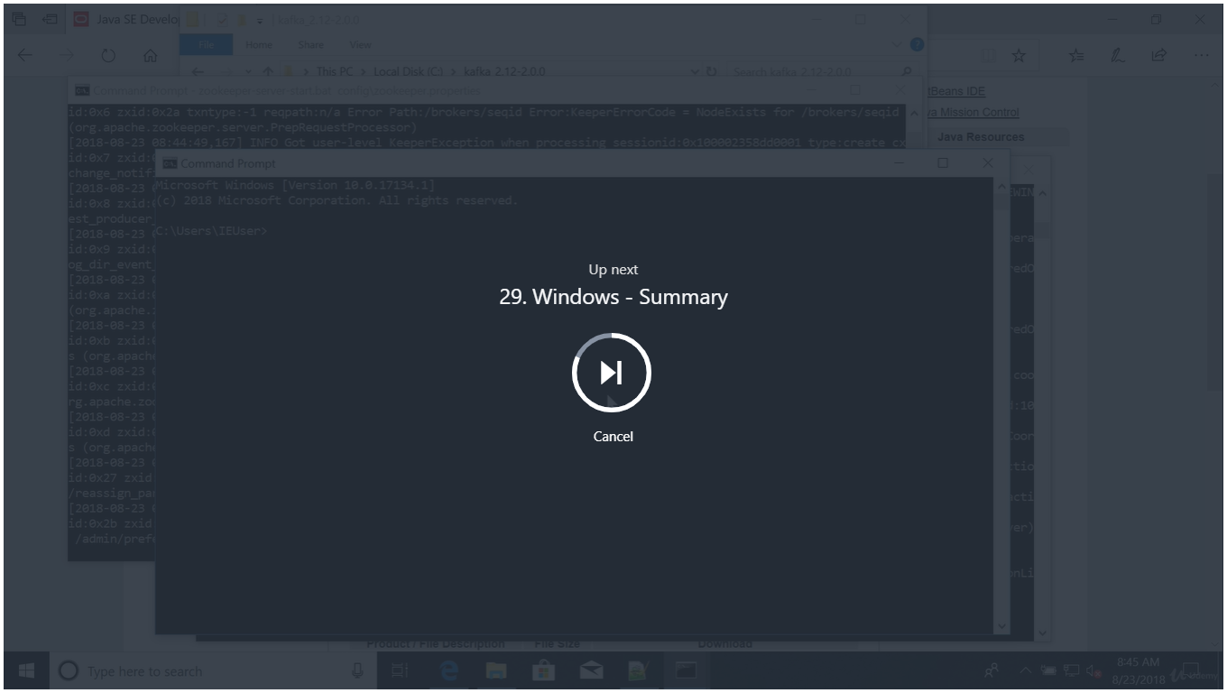

Windows - Summary

**In summary, for Windows**

1. Download and Setup **Java 8 JDK**
2. Download the Kafka binaries from <https://kafka.apache.org/downloads>
3. Extract Kafka at the root of C:\
4. Setup Kafka bins in the **Environment variables** section by editing **Path**
5. Try Kafka commands using kafka-topics.bat (for example)
6. Edit Zookeeper & Kafka configs using NotePad++ <https://notepad-plus-plus.org/download/>
   1. zookeeper.properties: dataDir=C:/kafka_2.12-2.0.0/data/zookeeper (yes the slashes are inversed)
   2. server.properties: log.dirs=C:/kafka_2.12-2.0.0/data/kafka (yes the slashes are inversed)
7. Start Zookeeper in one command line: zookeeper-server-start.bat config\zookeeper.properties
8. Start Kafka in **another** command line: kafka-server-start.bat config\server.properties

**Important: For the rest of the course, don't forget to add the extension .bat to commands being run**

Fullscreen

Go to Previous lecture

28. Windows - Start Zookeeper & Kafka

Go to Next lecture

30. CLI Introduction